**ROAD DETECTION**

**Group 1**

**GROUP MEMBERS:** Mohan Krishna Bhashyam, Rechitha Kosuri, Thoa Nguyen

## **1.** **Introduction**

Road detection is a popular topic for image processing and its applications are various. The goal of this project is to detect roads by using Hough Transform. Then, we will verify the results with the ground truth. Satellite images often contain noise, so the answer is not straightforward by using basic image processing.Hence, recent research showed that these images need to be preprocessed and enhanced before the extraction of objects [1].

The challenge that we need to overcome is the Hough Transform can detect only a few lines. In [2], the authors experiment their self-driving algorithm, which involves Hough Transform with hyperbola fitting, on real-life vehicles. However, the authors claimed that the algorithm detects only on slightly curved and straight roads, and there were some problems with lane detection under certain lighting conditions. The authors of [3] used several computer vision techniques for lane detection. In [3], the authors compared thresholding, warping, and pixel summation to Gaussian Blur, Canny Edge Detection, and Sliding Window Algorithm and found that the second approach was more accurate.We attempted different combinations of the image processing such as Canny Edge Detection or Hough Transform; however, we observed that we gained minimal performance improvement in terms of increasing the number of lines that could be detected.

## **2.** **Dataset**

In this project, we use two image datasets: original images and ground truth. For the original images, we have nine satellite images that contain crops, fields, and roads. The size of each image is 2048*2048 and .jpg format.

For the ground truth dataset, we manually generate for each image by using an online application called kleki.com. We have nine ground truth images corresponding to its original image. The size of each ground truth is 2048*2048 and .jpg format.

One example for the dataset and the ground truth are:

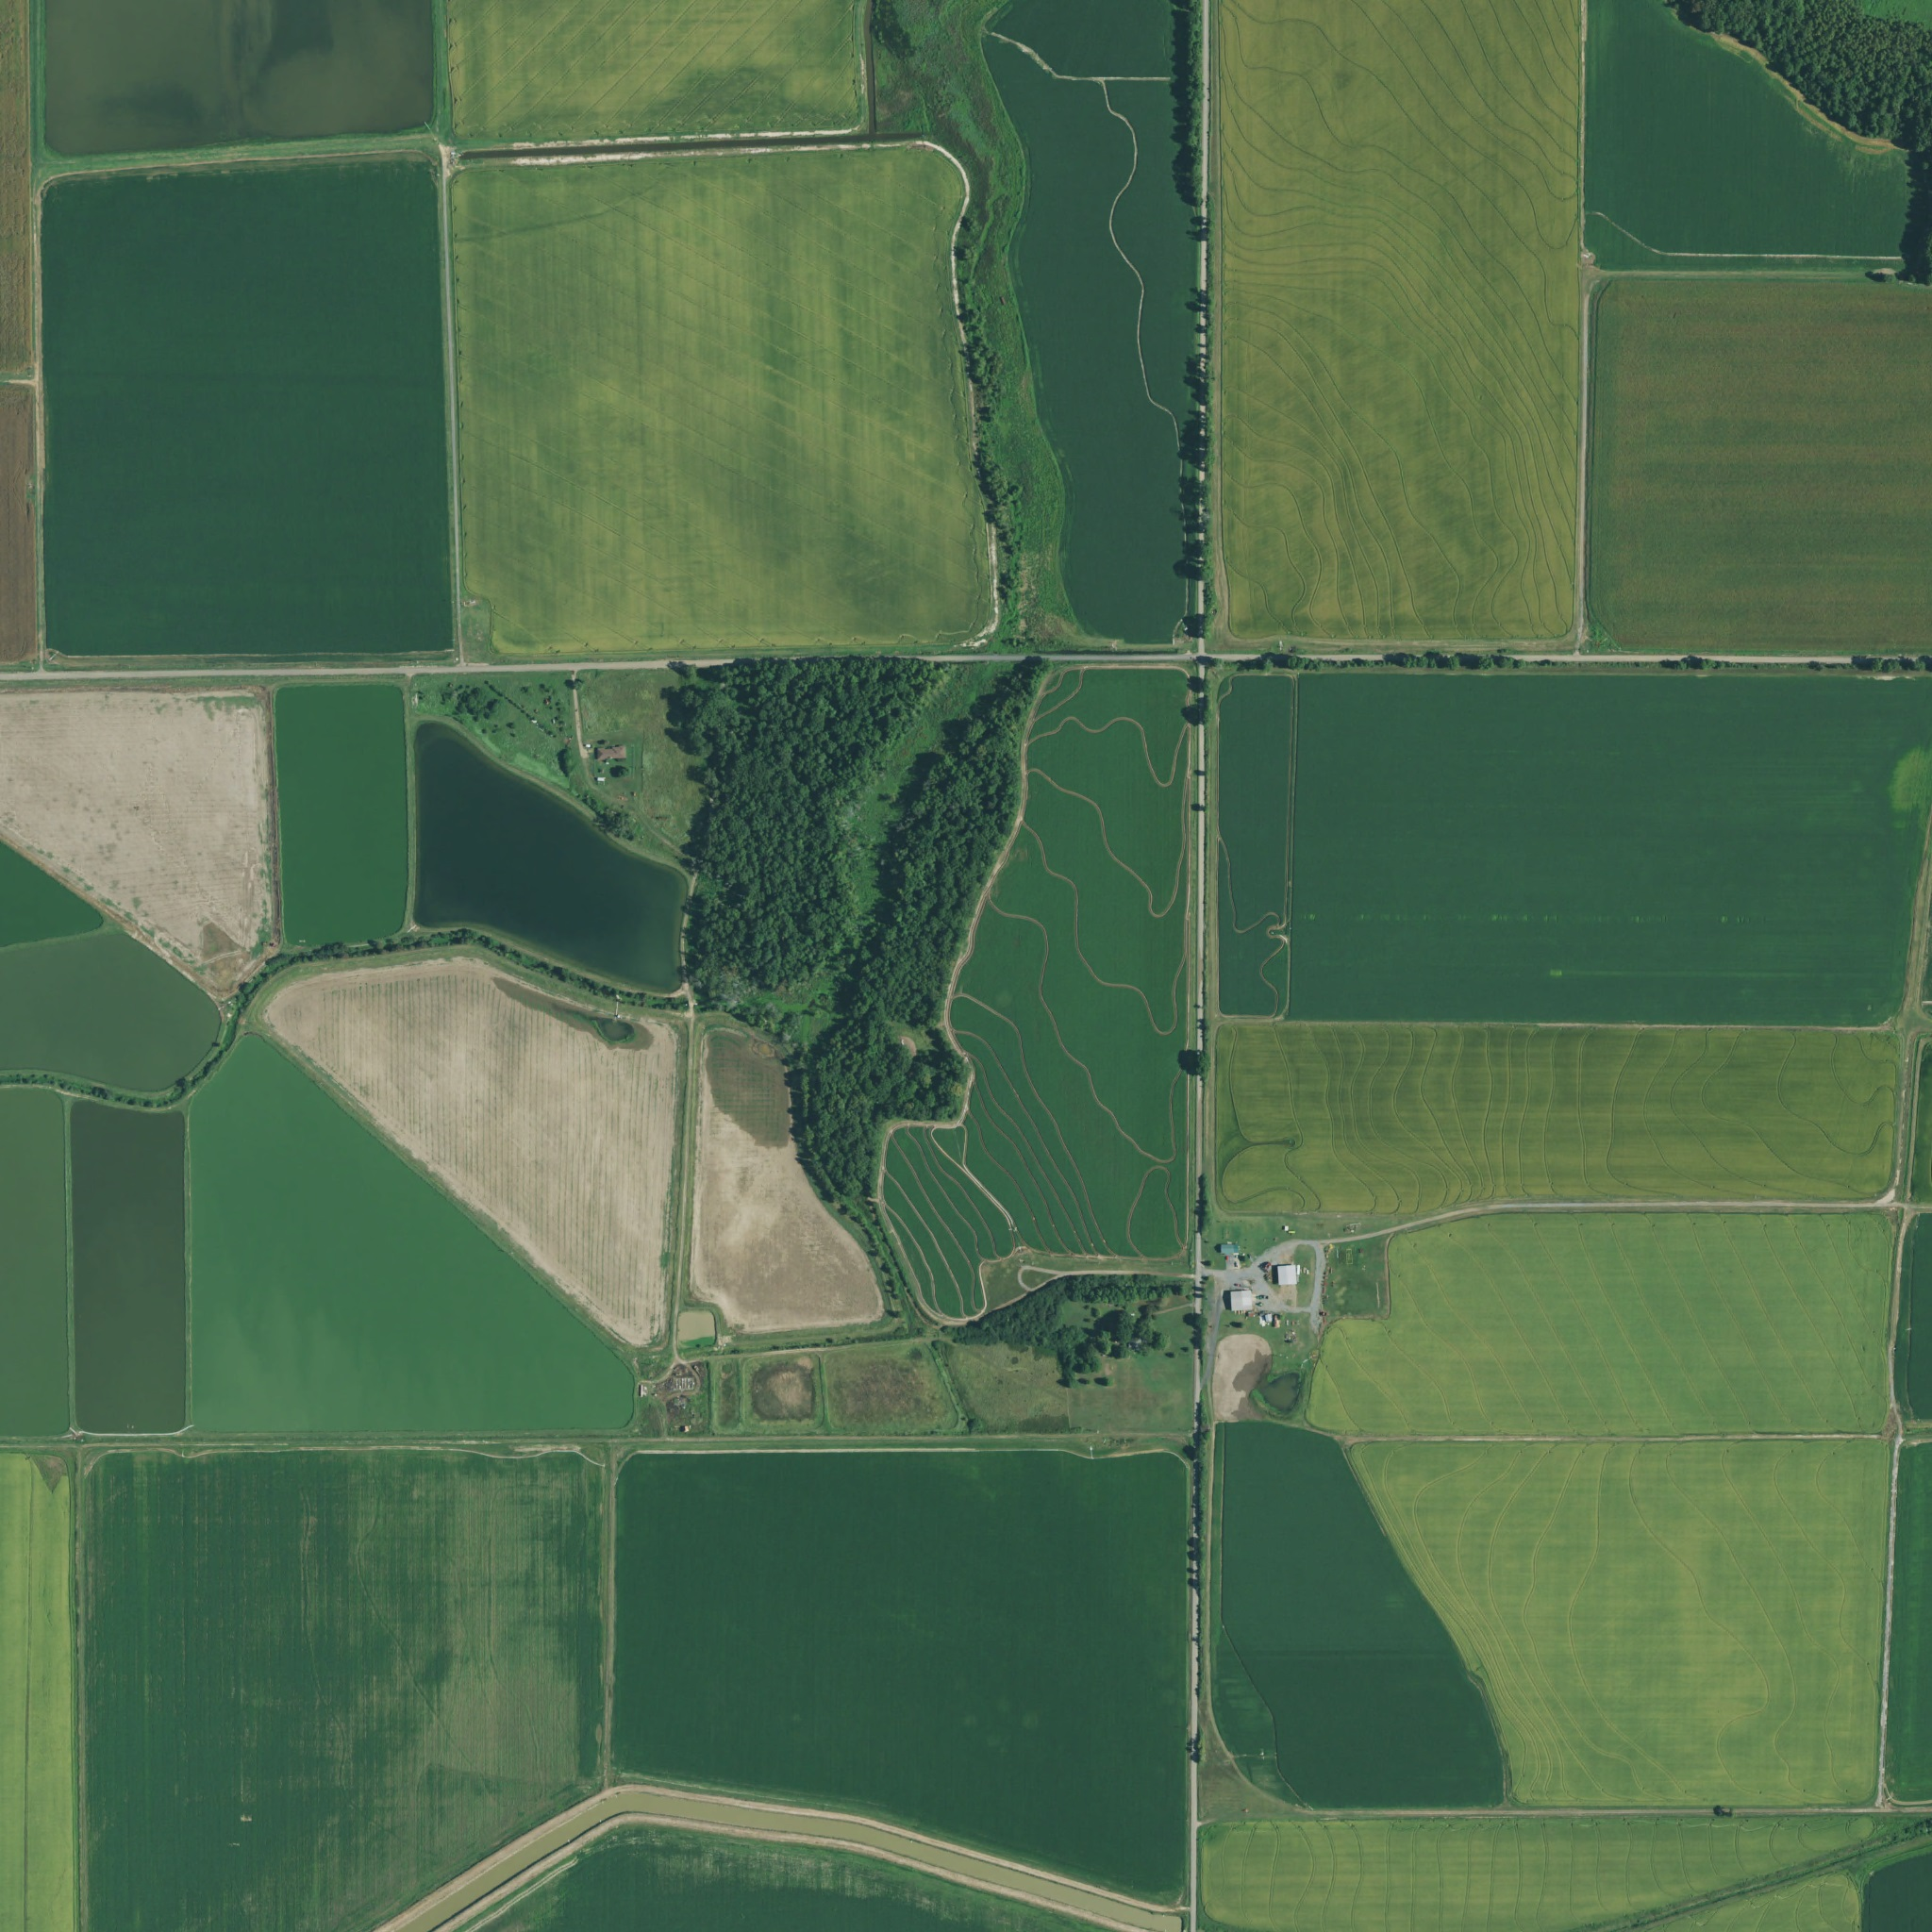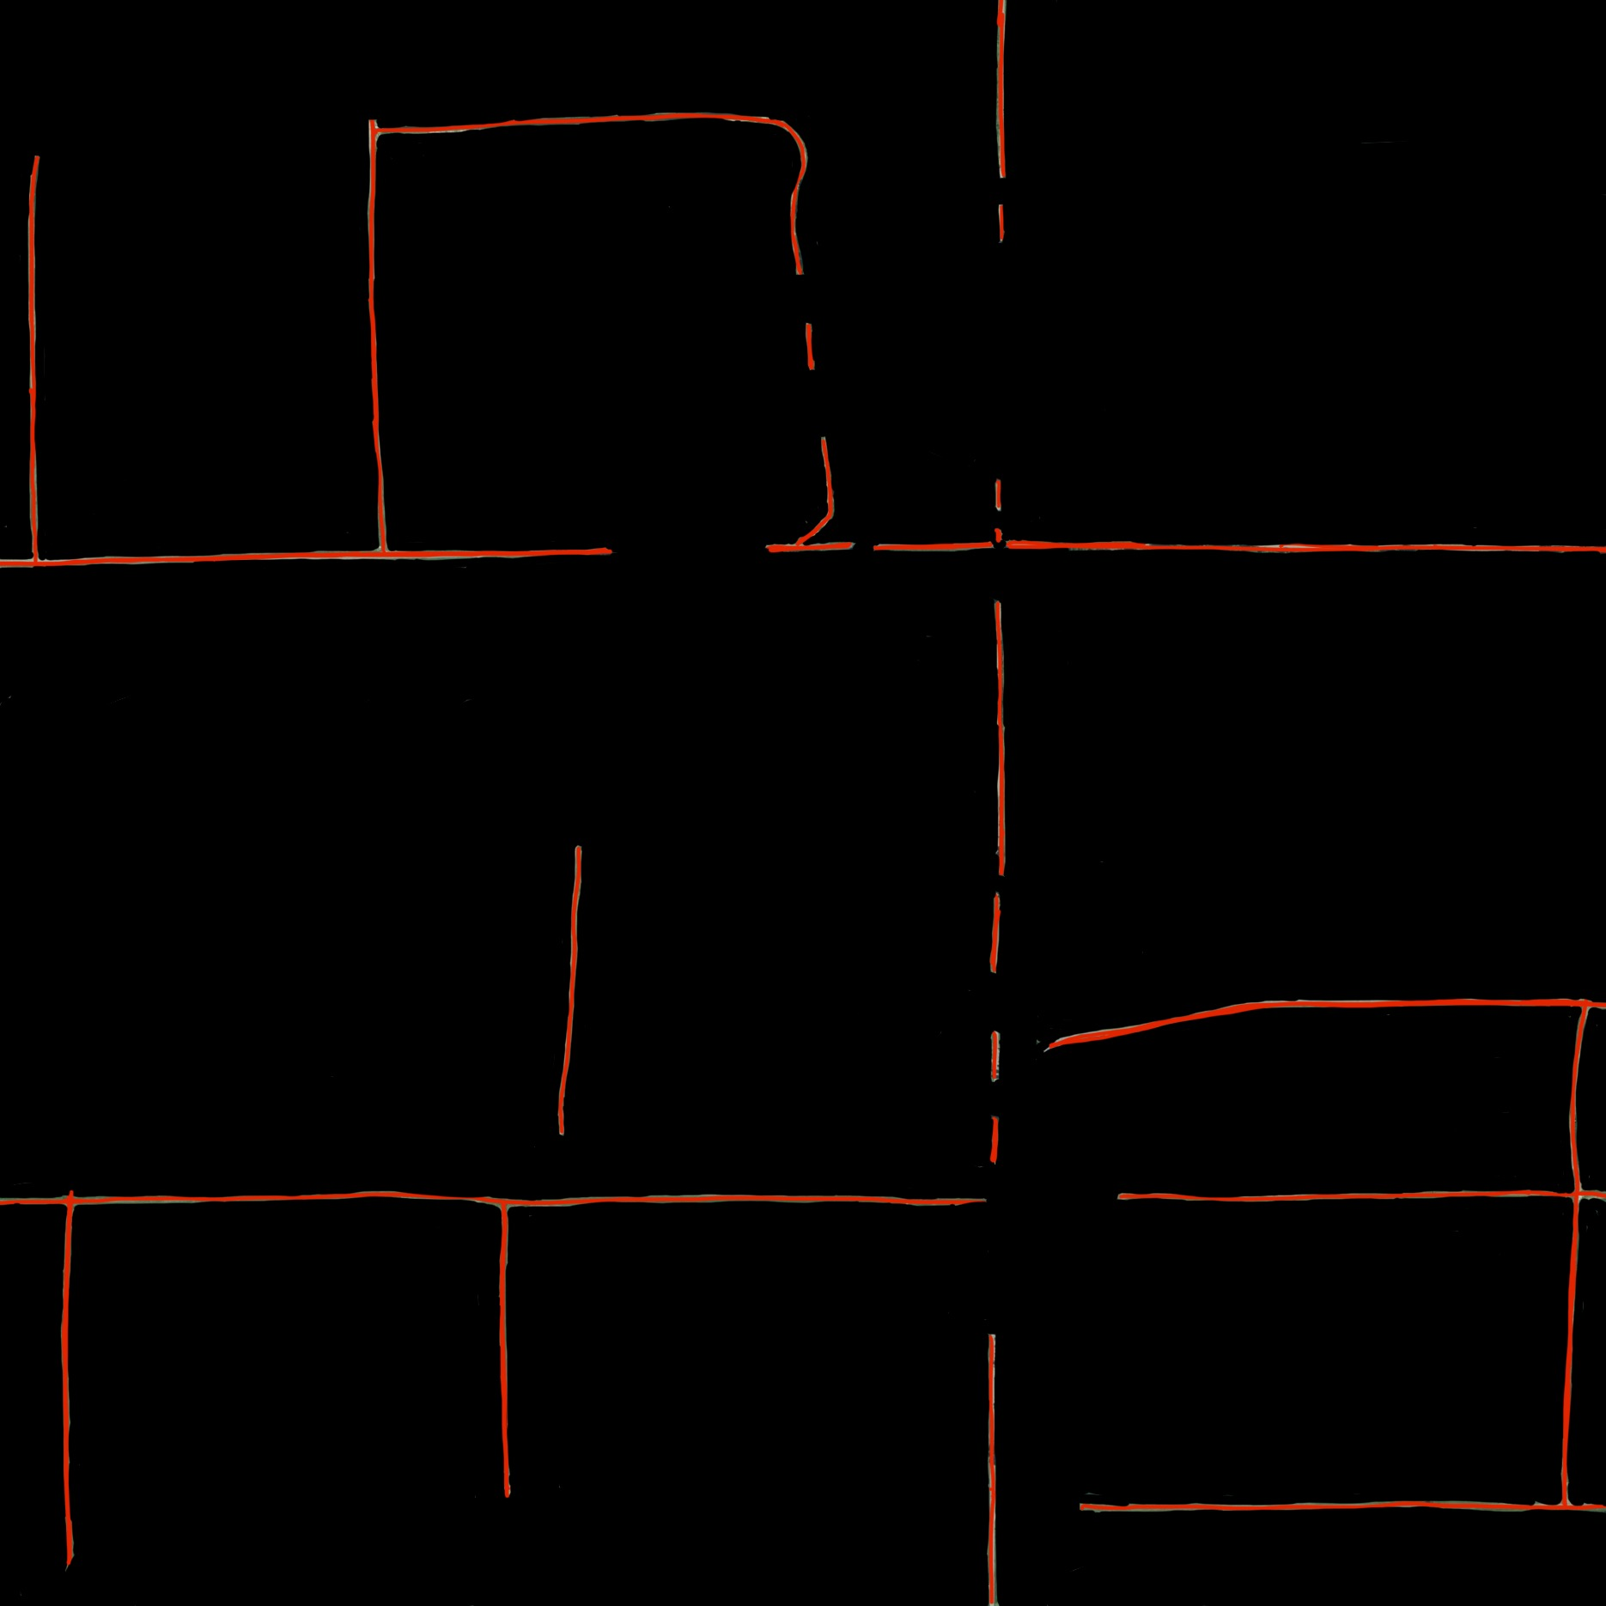

Original Image Ground Truth Image

## **3.** **Methodology**

The following flowchart demonstrates the image processing methods that we used in the project. The process is divided into three main steps: Image Preprocessing, Image Processing and Evaluate. The details of each step will be discussed below.

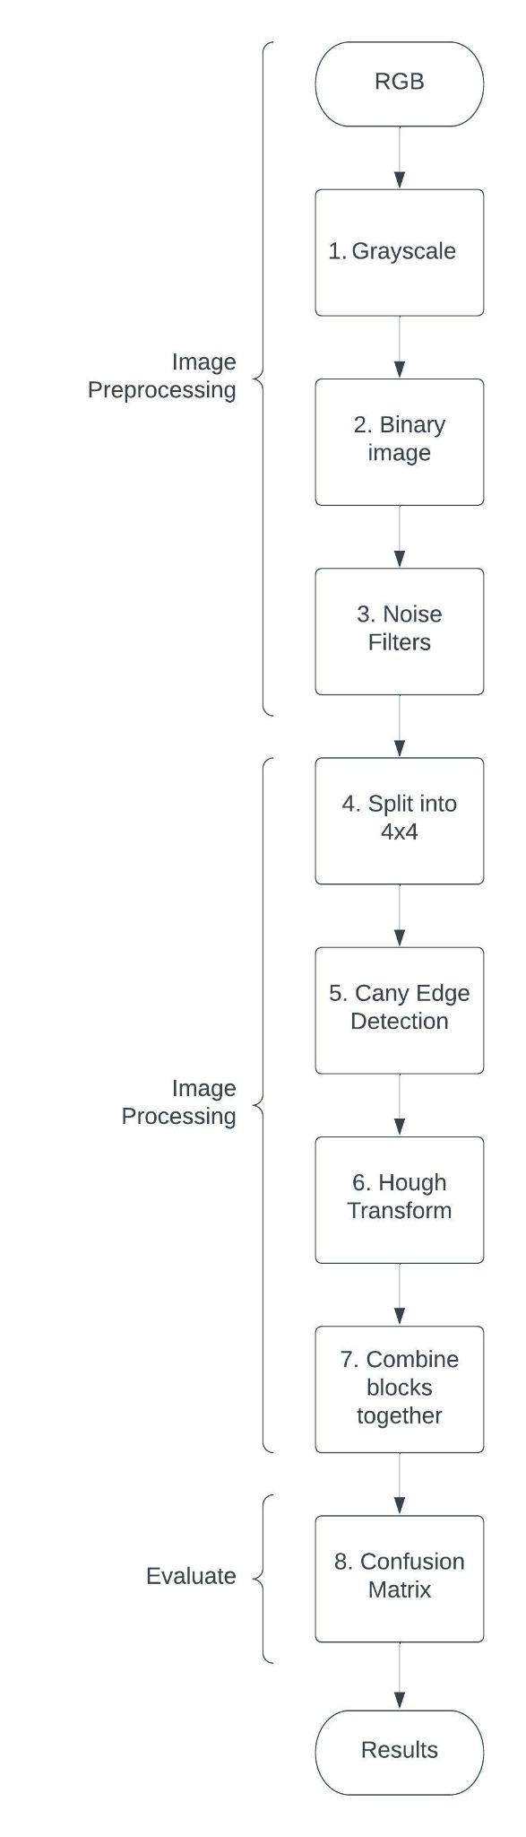

### **I. Image Preprocessing**

Our dataset includes nine images which are in satellite and contain lots of noise. Therefore, these images need to be preprocessed and enhanced. In this step, we convert these images into Grayscale images, and binary images; perform morphological operations. Hence, resultant images are more appropriate for analysis. It improves the appearance of the roads and removes the noise.

1. Convert RGB image into Grayscale image using im2gray() function
2. Convert Grayscale image to binary image using imbinarize() function
3. To remove noise, we perform following operations below:
4. Apply s = strel('disk',5,0) to defiance the structuring element. We chose disk-shaped SE of radius 5
5. Apply F = imerode() function to perform erosion operation
6. To remove noises, we perform binary image minus F
7. Apply second noise filtering by using bwareaopen(). We will remove objects containing fewer than 50 pixels.

### **II. Image Processing**

In this step, we use Hough Transform as a main method to detect the roads along with Canny Edge Detection. We split an image into 4x4 and then apply the Edge Detection as well as Hough Transform. The reason why we split the image is because we observed that Hough Transform could work better and we may possibly get good results.

4. Split the image into 4x4

5. Apply Canny Edge Detection to each block.

6. Apply Hough Transform to each block.

7. Combine each block in order horizontally and vertically. We could resize back to its original size.

### **III. Evaluation**

In this step, we demonstrate the performance qualitatively and quantitatively. A side-by-side comparison of the ground truth and the results gives a qualitative illustration. We use confusion as a numerical metric to perform the quantitative evaluation, instead of comparing the red line pixels.

On our first evaluation method, the limitations of comparing the red line pixels are that it is not reliable or effective. For example, it will count red pixels appearing in the image even though these red pixels do not form a line in the correct way. As a consequence, it affects the accuracy rate. We use the operation below to calculate the red pixels. Note that img is the image that we want to calculate the red pixels.

redPoints = img(:,:,1)>=130 & img(:,:,2)<=60 & img(:,:,3)<=100;

In the latest update, we use the confusion matrix which calculates the true positives, true negatives, false negatives, false positives. We use these values from the confusion matrix to calculate the accuracy.

## **4.** **Experimental Results**

### **First Demonstration:**

In this section, we perform our results corresponding to the first evaluation method we used. Note that we split an image into 3x3 and compare red line pixels manually for each and every block and get the following results.

In this process, after we divide images into 9 blocks, the parameters are changed for each block which is not a general method to apply.These images got better results as these blocks of images got individual improvement.

* **field.jpg**





Extract red pixels to calculate number of pixels:



| Ground Truth | Result | Accuracy Rate |
| --- | --- | --- |
| 40924 red pixels | 25389 red pixels | 62.04% |

For the field.jpg image, the accuracy rate is 62.02%. Obviously, the result was missing some long lines and detecting some random lines which are not supposed to be detected.

* **L88a.jpg**





Extract red pixels to calculate number of pixels:



| Ground Truth | Result | Accuracy Rate |
| --- | --- | --- |
| 19883 red pixels | 16813 red pixels | 84.56% |

For the L88a.jpg image, the accuracy rate is 84.56%. Even though the accuracy rate is quite high, the result is not correct as expected. We could see that the houghline function detects four random lines, which are not supposed to detect as a line. As a consequence, the number of lines in the result image exceeds the number of lines in the ground truth.

* **L88b.jpg**





Extract red pixels to calculate number of pixels:



| Ground Truth | Result | Accuracy Rate |
| --- | --- | --- |
| 22968 red pixels | 12524 red pixels | 54.53% |

For the L88b.jpg image, the accuracy rate is 54.53%, which is much lower. In this case, we can say that the houghline function can barely detect correct lines. It was missing many lines and detecting many other random lines.

* **L96a.jpg**







| Ground Truth | Result | Accuracy Rate |
| --- | --- | --- |
| 20790 red pixels | 10075 red pixels | 48.46% |

For the L96a.jpg image, the accuracy rate is 48.46%, which is a failure for the method. The houghline function does not even detect random noise as a line but the lines which are detected, are discrete.

* **L96b.jpg**





Extract red pixels to calculate number of pixels:



| Ground Truth | Result | Accuracy Rate |
| --- | --- | --- |
| 21764 red pixels | 11176 red pixels | 51.35% |

For the L96b.jpg image, the accuracy rate is 51.35%, which is much lower. In this case, we can say that the houghline function can barely detect correct lines. It was missing many lines and detecting many other random lines.

* **L97a.jpg**





Extract red pixels to calculate number of pixels:



| Ground Truth | Result | Accuracy Rate |
| --- | --- | --- |
| 26326 red pixels | 16180 red pixels | 61.46% |

For the L97a.jpg image, the accuracy rate is 61.46%, which is quite acceptable. The good news is that the houghline function is able to detect the correct number of lines.

* **L97b.jpg**





Extract red pixels to calculate number of pixels:



| Ground Truth | Result | Accuracy Rate |
| --- | --- | --- |
| 20134 red pixels | 12875 red pixels | 63.95% |

For the L97b.jpg image, the accuracy rate is 63.95%, which is acceptable. Again, there are some missing lines and random noise is detected as a line.

* **W107a.jpg**





Extract red pixels to calculate number of pixels:



| Ground Truth | Result | Accuracy Rate |
| --- | --- | --- |
| 15568 red pixels | 14330 red pixels | 92.05% |

For the W107a.jpg image, the accuracy rate is 92.05%, which is quite high. However, the houghline function detects too much random noise as a line.

* **W107b.jpg**





Extract red pixels to calculate number of pixels:



| Ground Truth | Result | Accuracy Rate |
| --- | --- | --- |
| 28704 red pixels | 20833 red pixels | 72.58% |

For the W107b.jpg image, the accuracy rate is 72.58%, which is acceptable. However, the houghline function detects too much random noise as a line.

This Method is not considered as a general method that should be applied for all the images. In the next methods, we developed a generalised function which can be applied for any image that we take.

### **Latest Updates which are considered as failures:**

### In this section**,** we are presenting some of our results and explain why we considered these models are not considered as success.

In this section, we are going to show results of two methods

1. Results got by dividing the image into 2*2 image i.e 4 blocks
2. Results got by dividing the image into 3*3 image i.e 9 blocks

**Results got by dividing the image into 2*2 image i.e 4 blocks**

* **W107b.jpg**

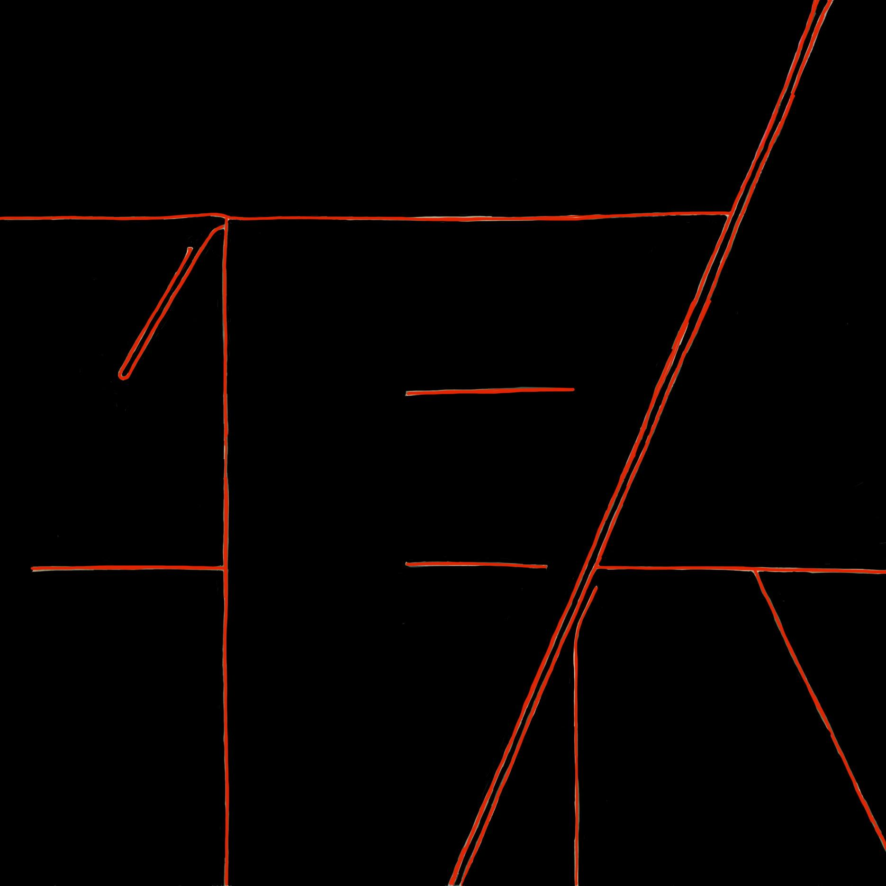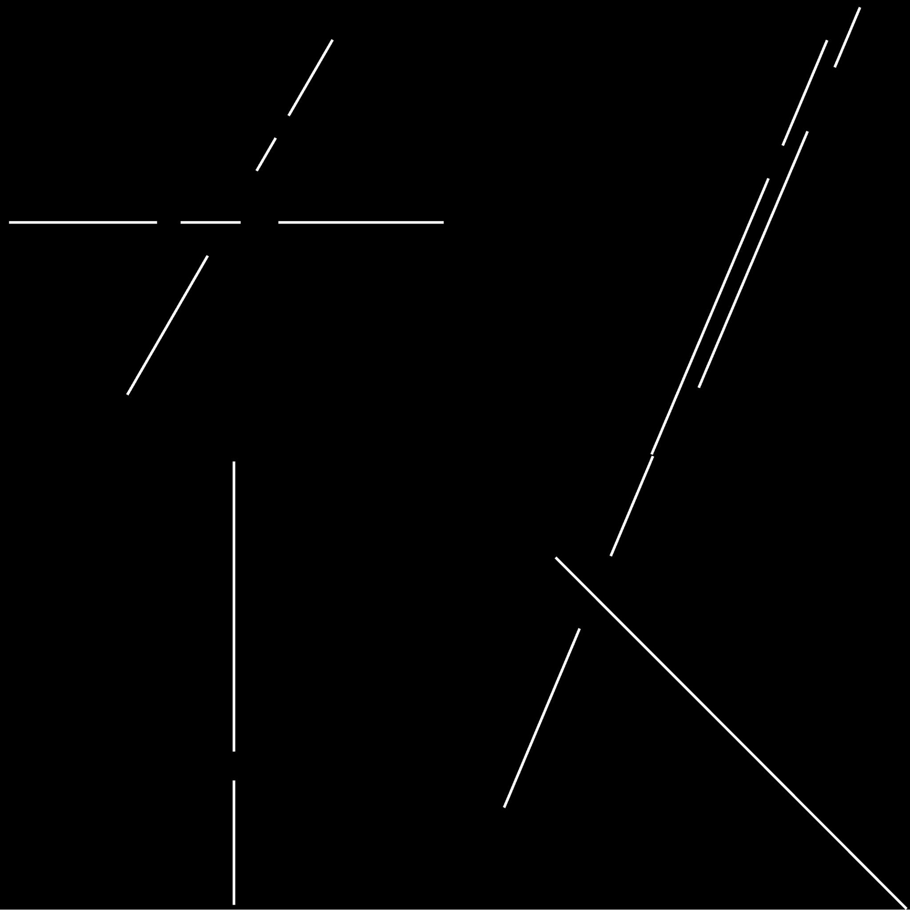

Ground Truth Result

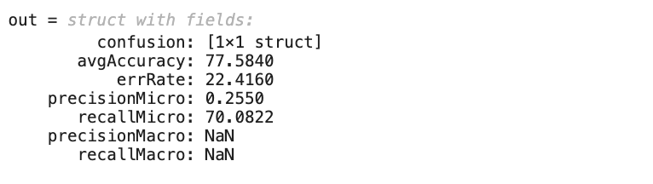

Accuracy from the Confusion Matrix

This is when we divided the image into 4 blocks where we got 77% accuracy and very less precision and recall. Whereas in the next methods we got better results. This is just an example but all the results are the same as this image. So, we considered this method a failure.

**Results got by dividing the image into 3*3 image i.e 9 blocks**

* **W107b.jpg**

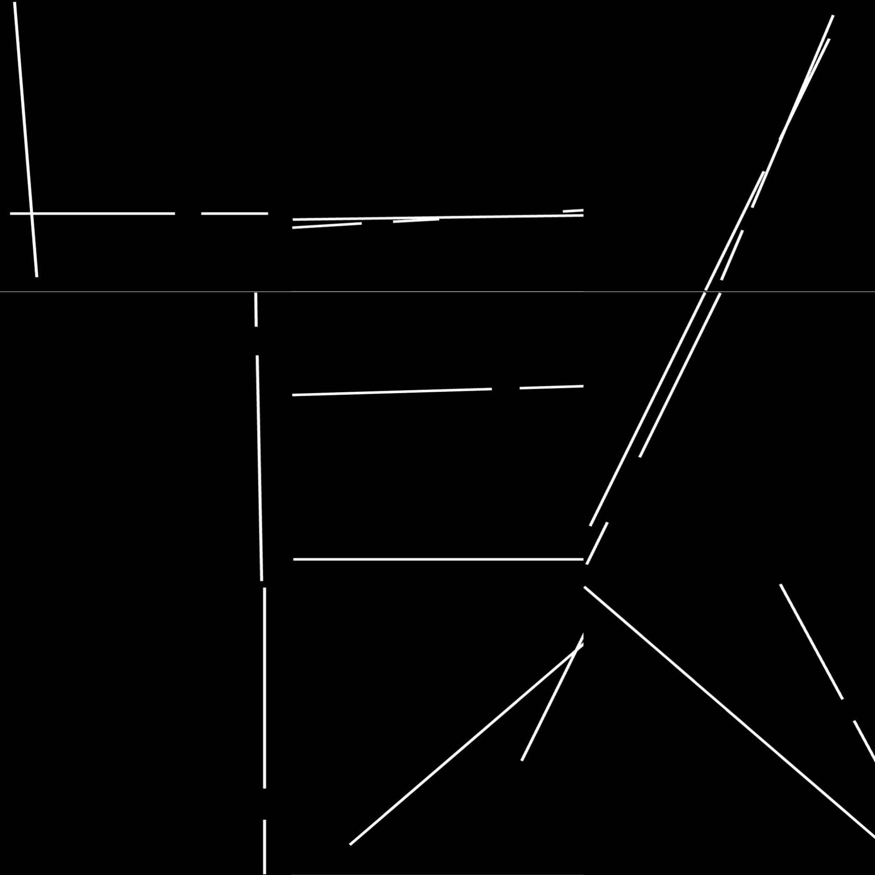

Ground Truth Result

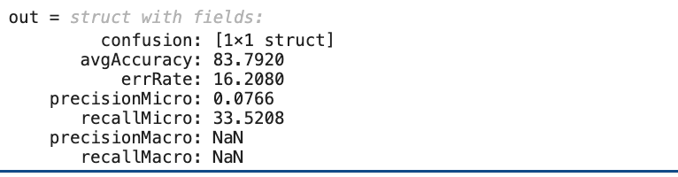

Accuracy from the Confusion Matrix

This is when we divided the image into 9 blocks where we got 83% accuracy and very less precision and recall. Whereas in the next method we got better results. This is just an example but all the results are the same as this image. So, we considered this method also a failure.

### **Latest Updates which are considered as success:**

In this section, we present our latest updates. We split the image into 4x4 and improve our evaluation method. In general, by splitting the image into 4x4, the houghline function performs a better result. Also, we use the confusion matrix as a new evaluation method instead of calculating the red line pixels. As we mentioned above, comparing the red line pixels is not an ideal method.

* **Field.jpg**

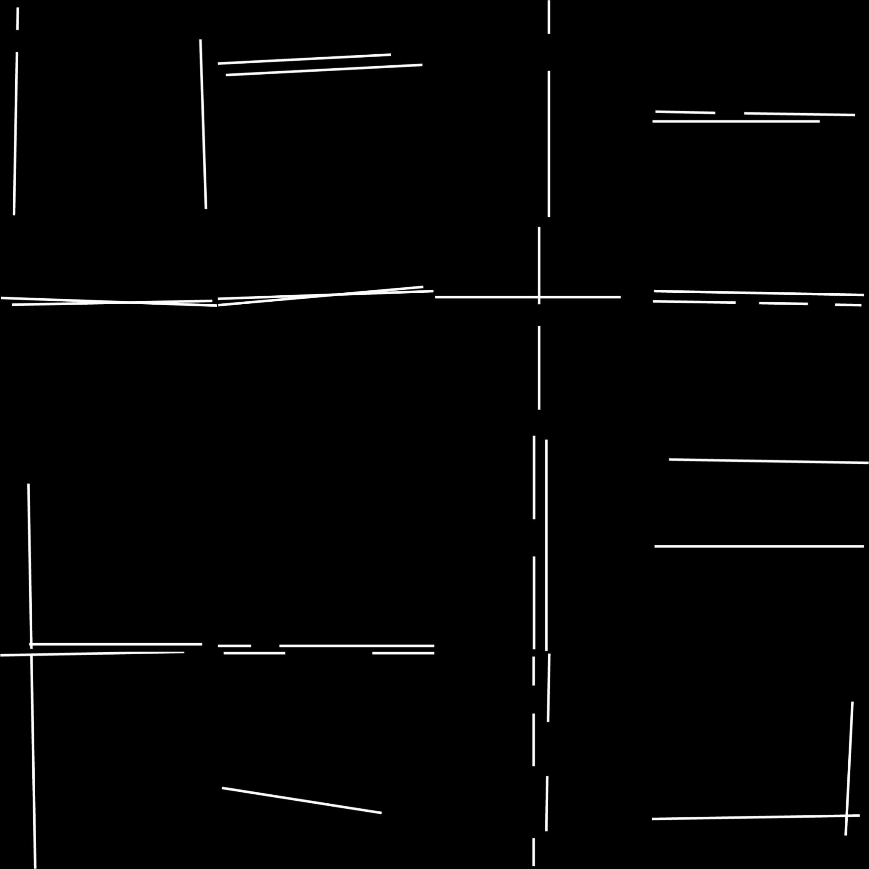

Ground Truth Result

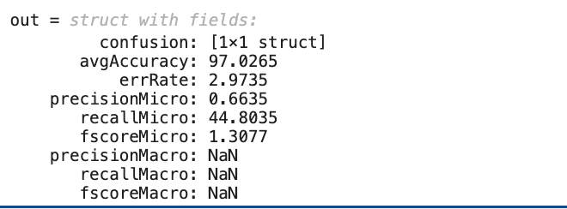

Accuracy from the Confusion Matrix

For field.jpg the accuracy is 97.0265 which is great and by looking at both of the images we can say they are very similar.

* **L88a.jpg**

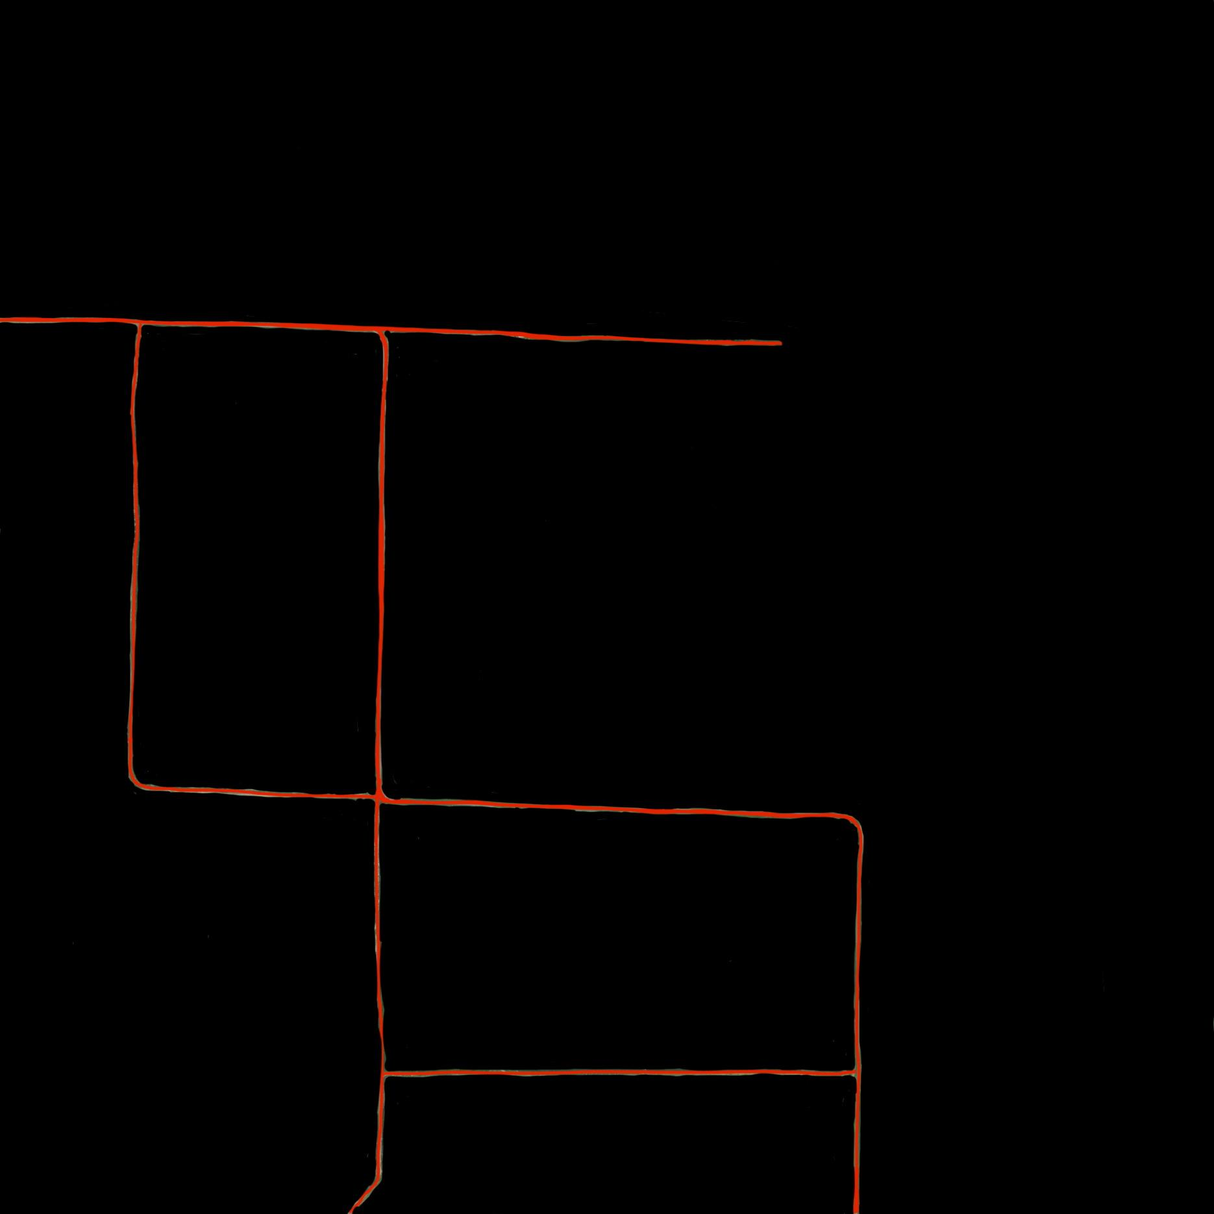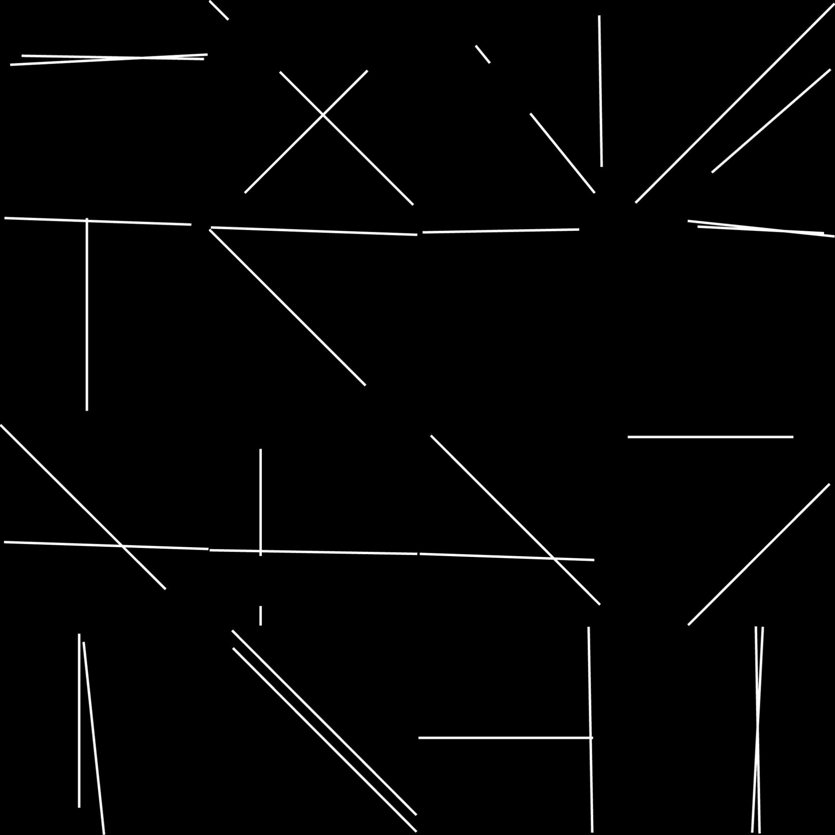

Ground Truth Result

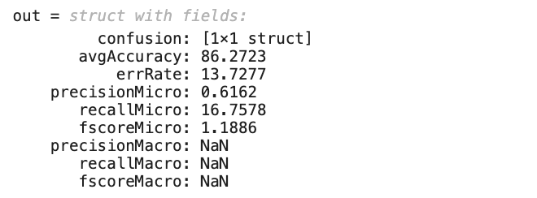

Accuracy from the Confusion Matrix

For L88a.jpg the accuracy is 86.2723 which is good but there are more negatives in the result which increases the error

* **L88b.jpg**

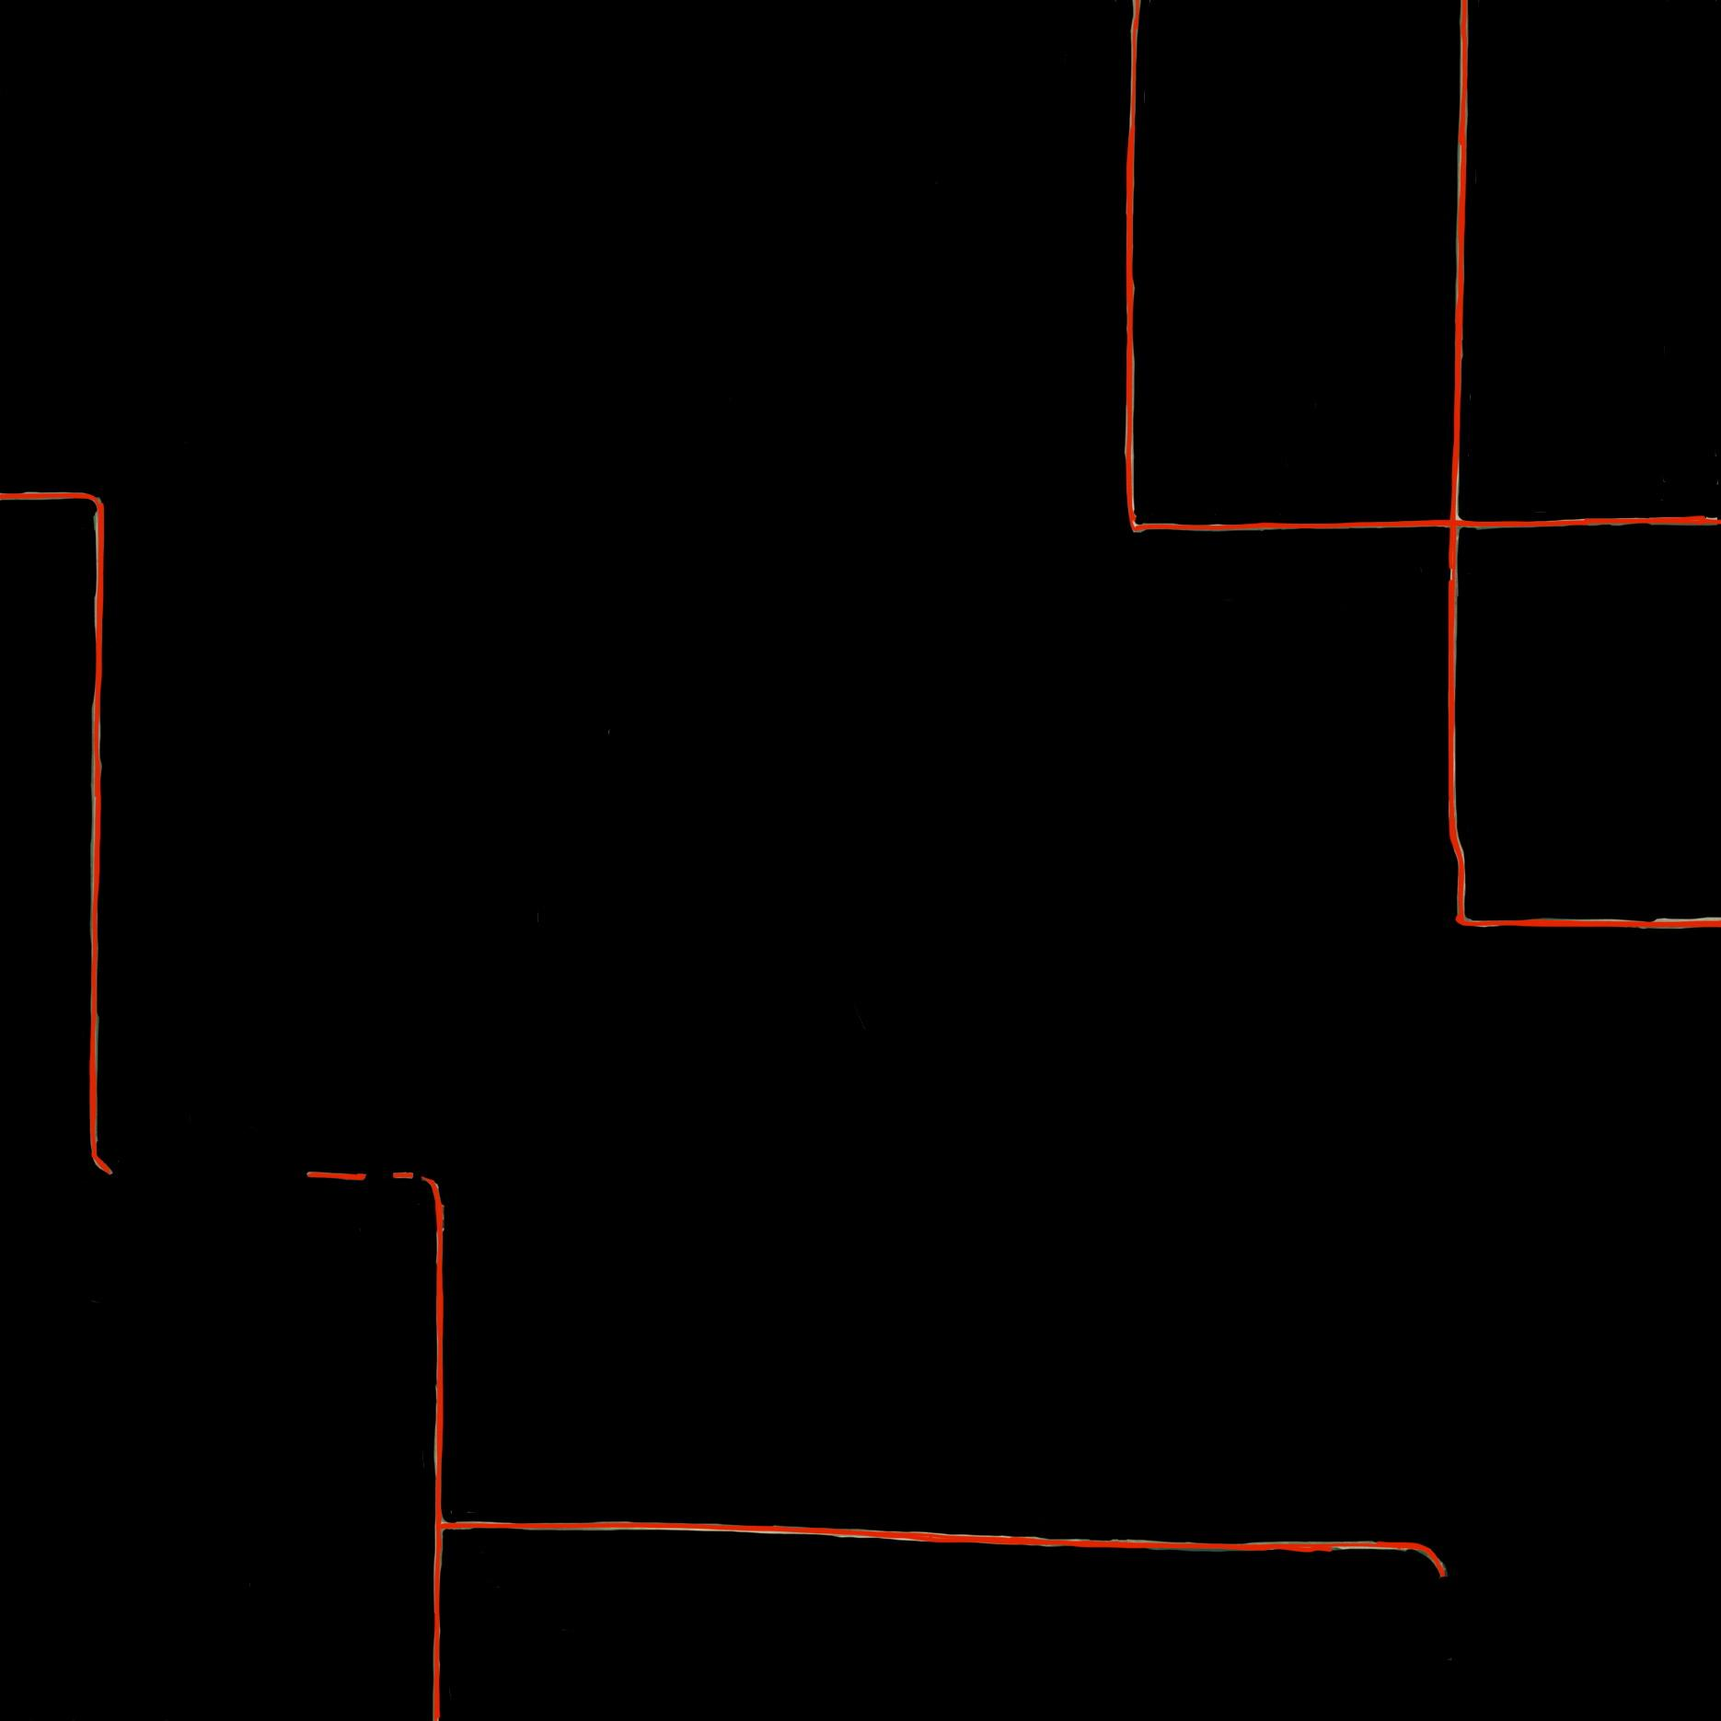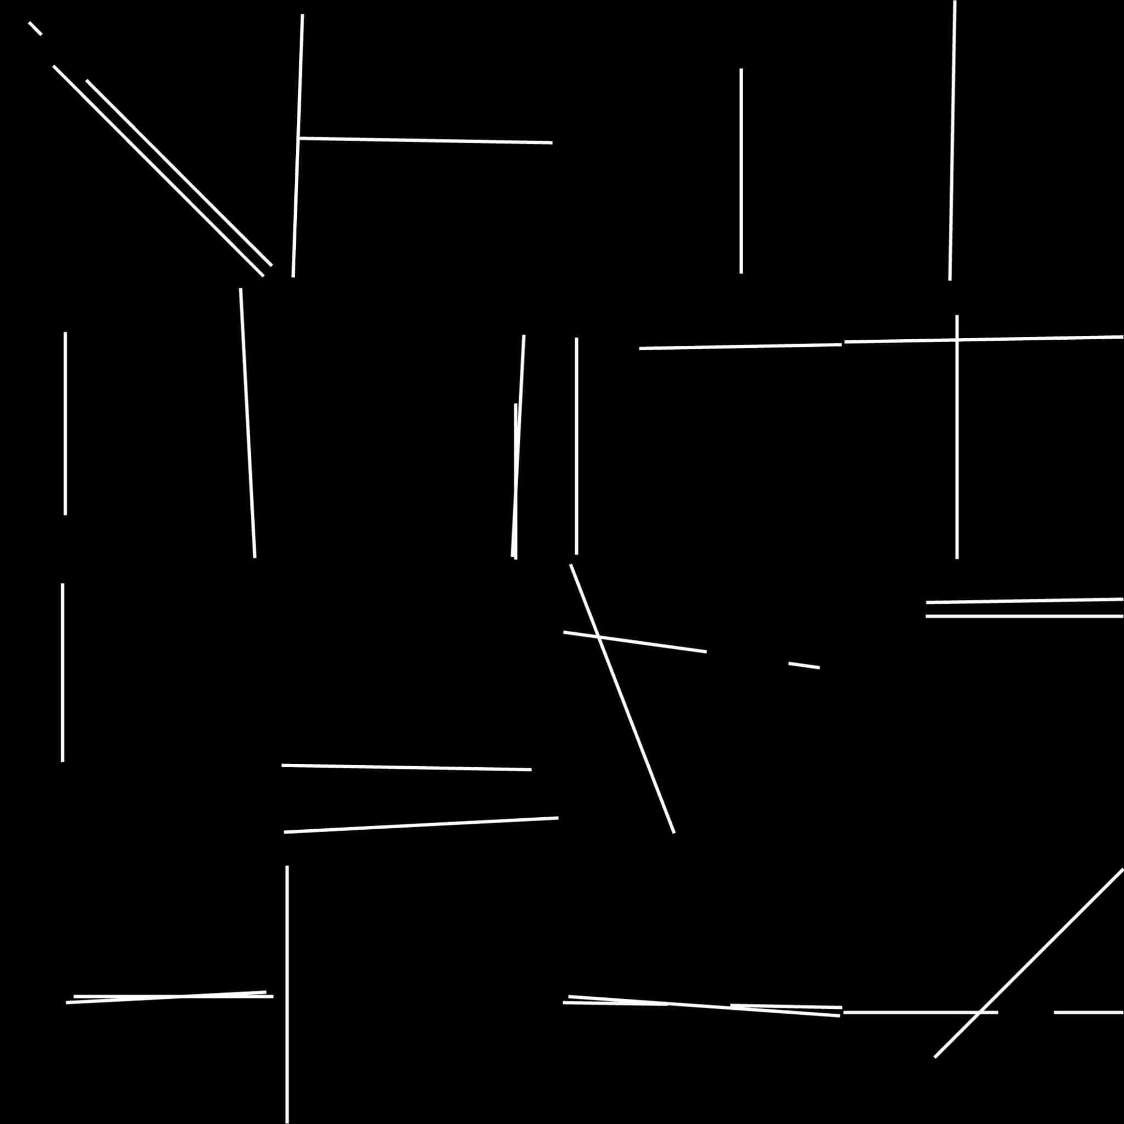

Ground Truth Result

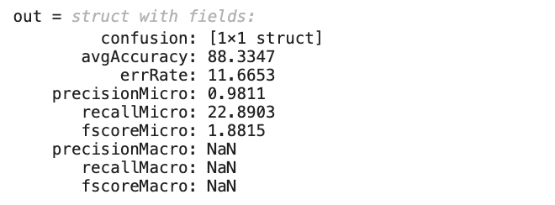

Accuracy from the Confusion Matrix

For L88b.jpg the accuracy is 88.3347 which is good but there are more negatives in the result and the shape was not so great from looking which increases the error

* **L96a.jpg**

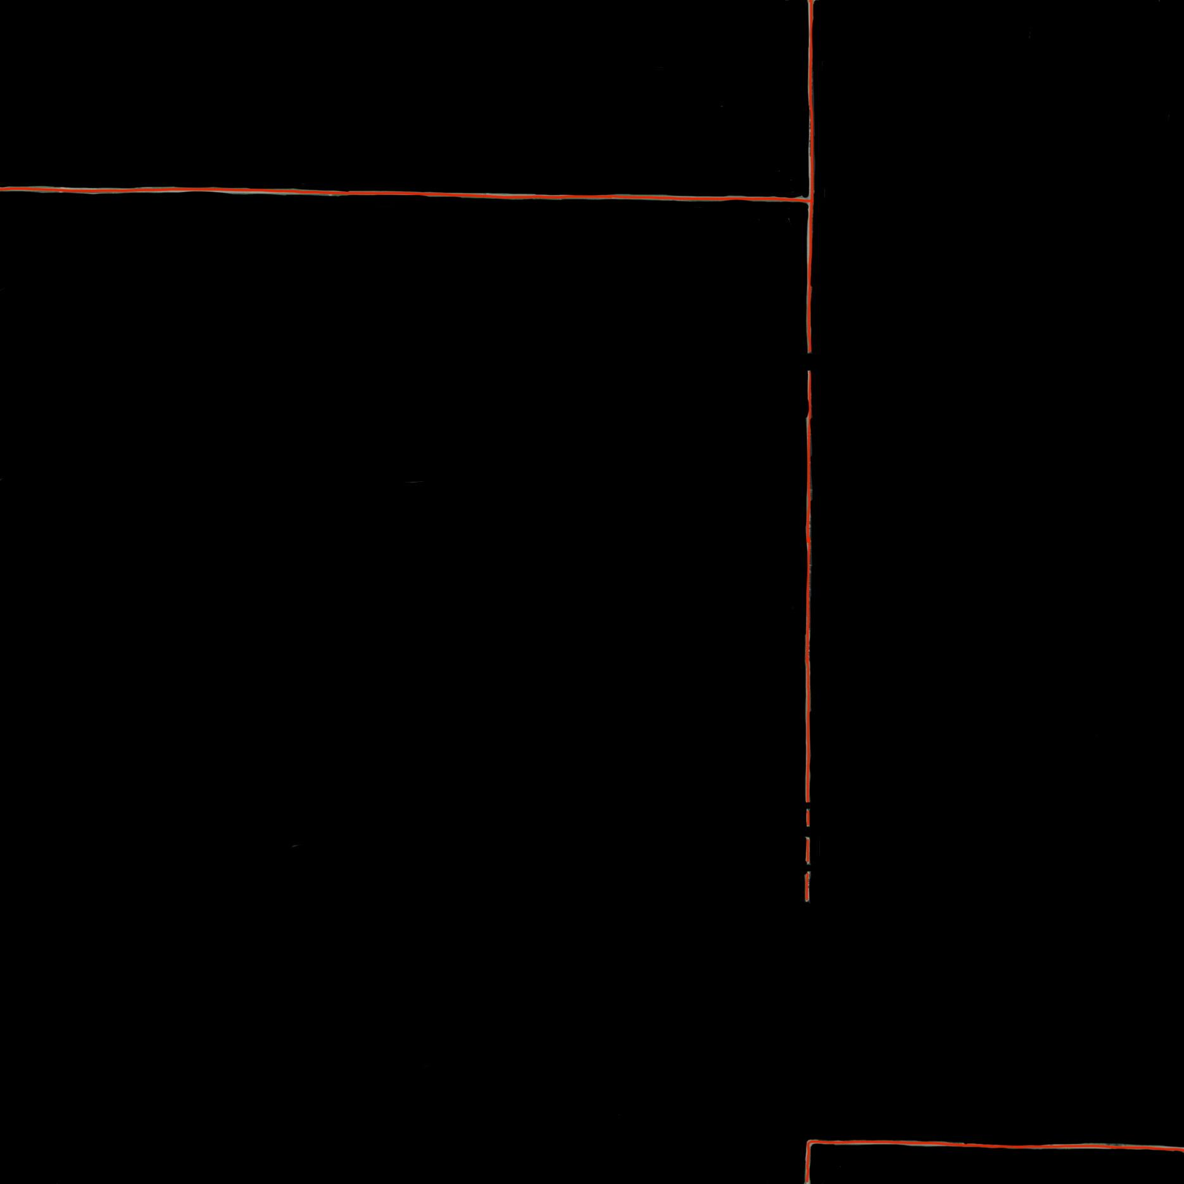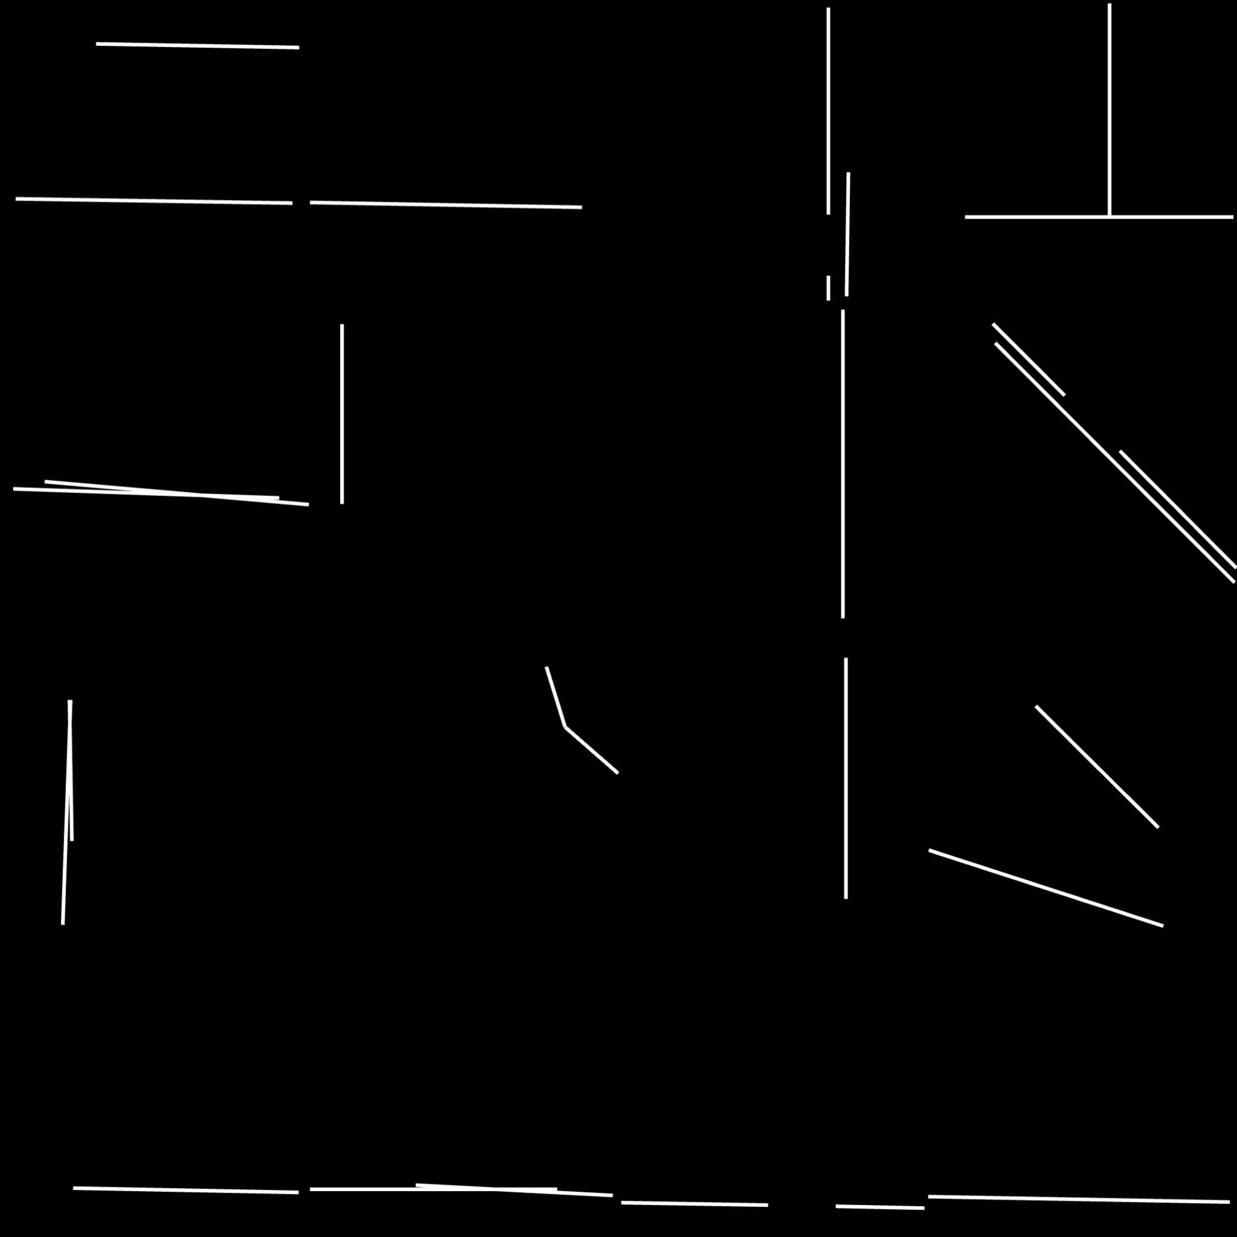

Ground Truth Result

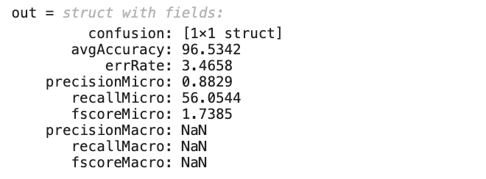

Accuracy from the Confusion Matrix

For L96a.jpg the accuracy is 96.5342 which is great and the shape was looking great

* **L96b.jpg**

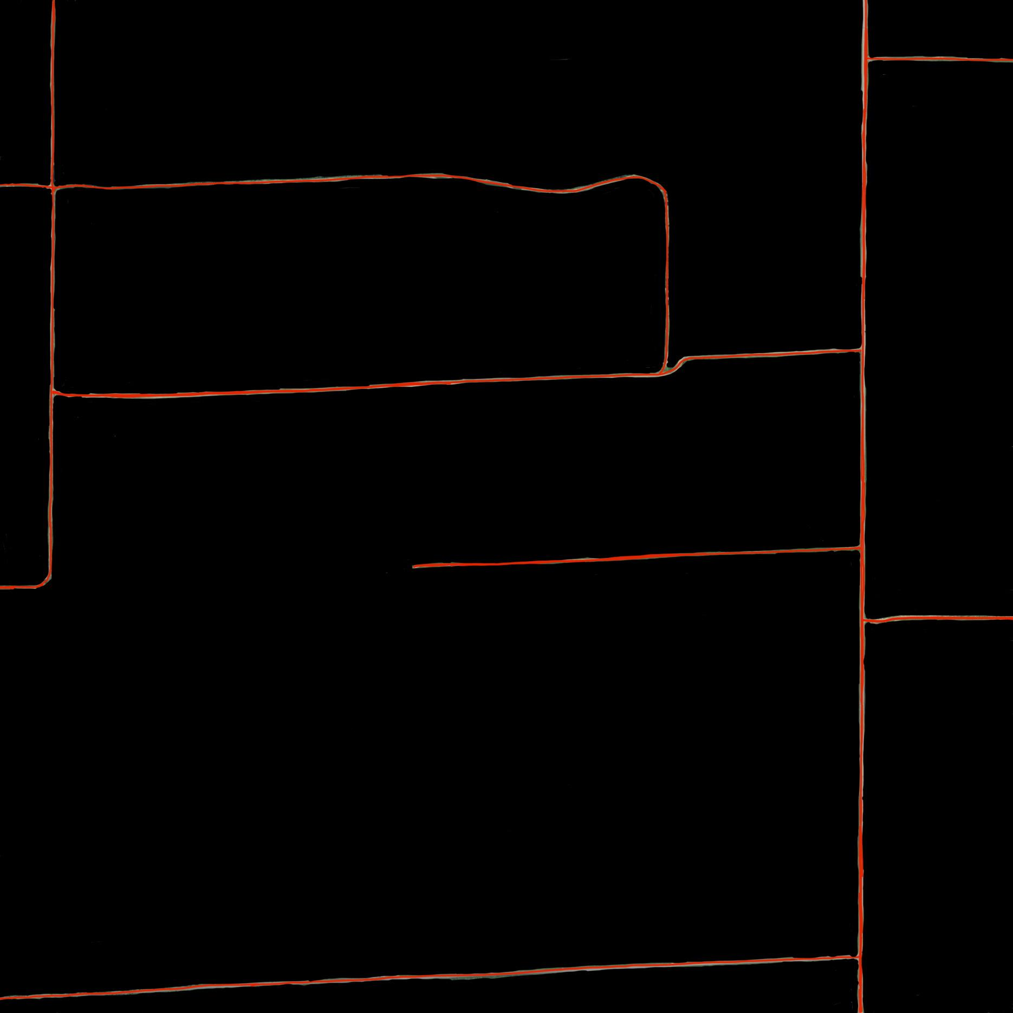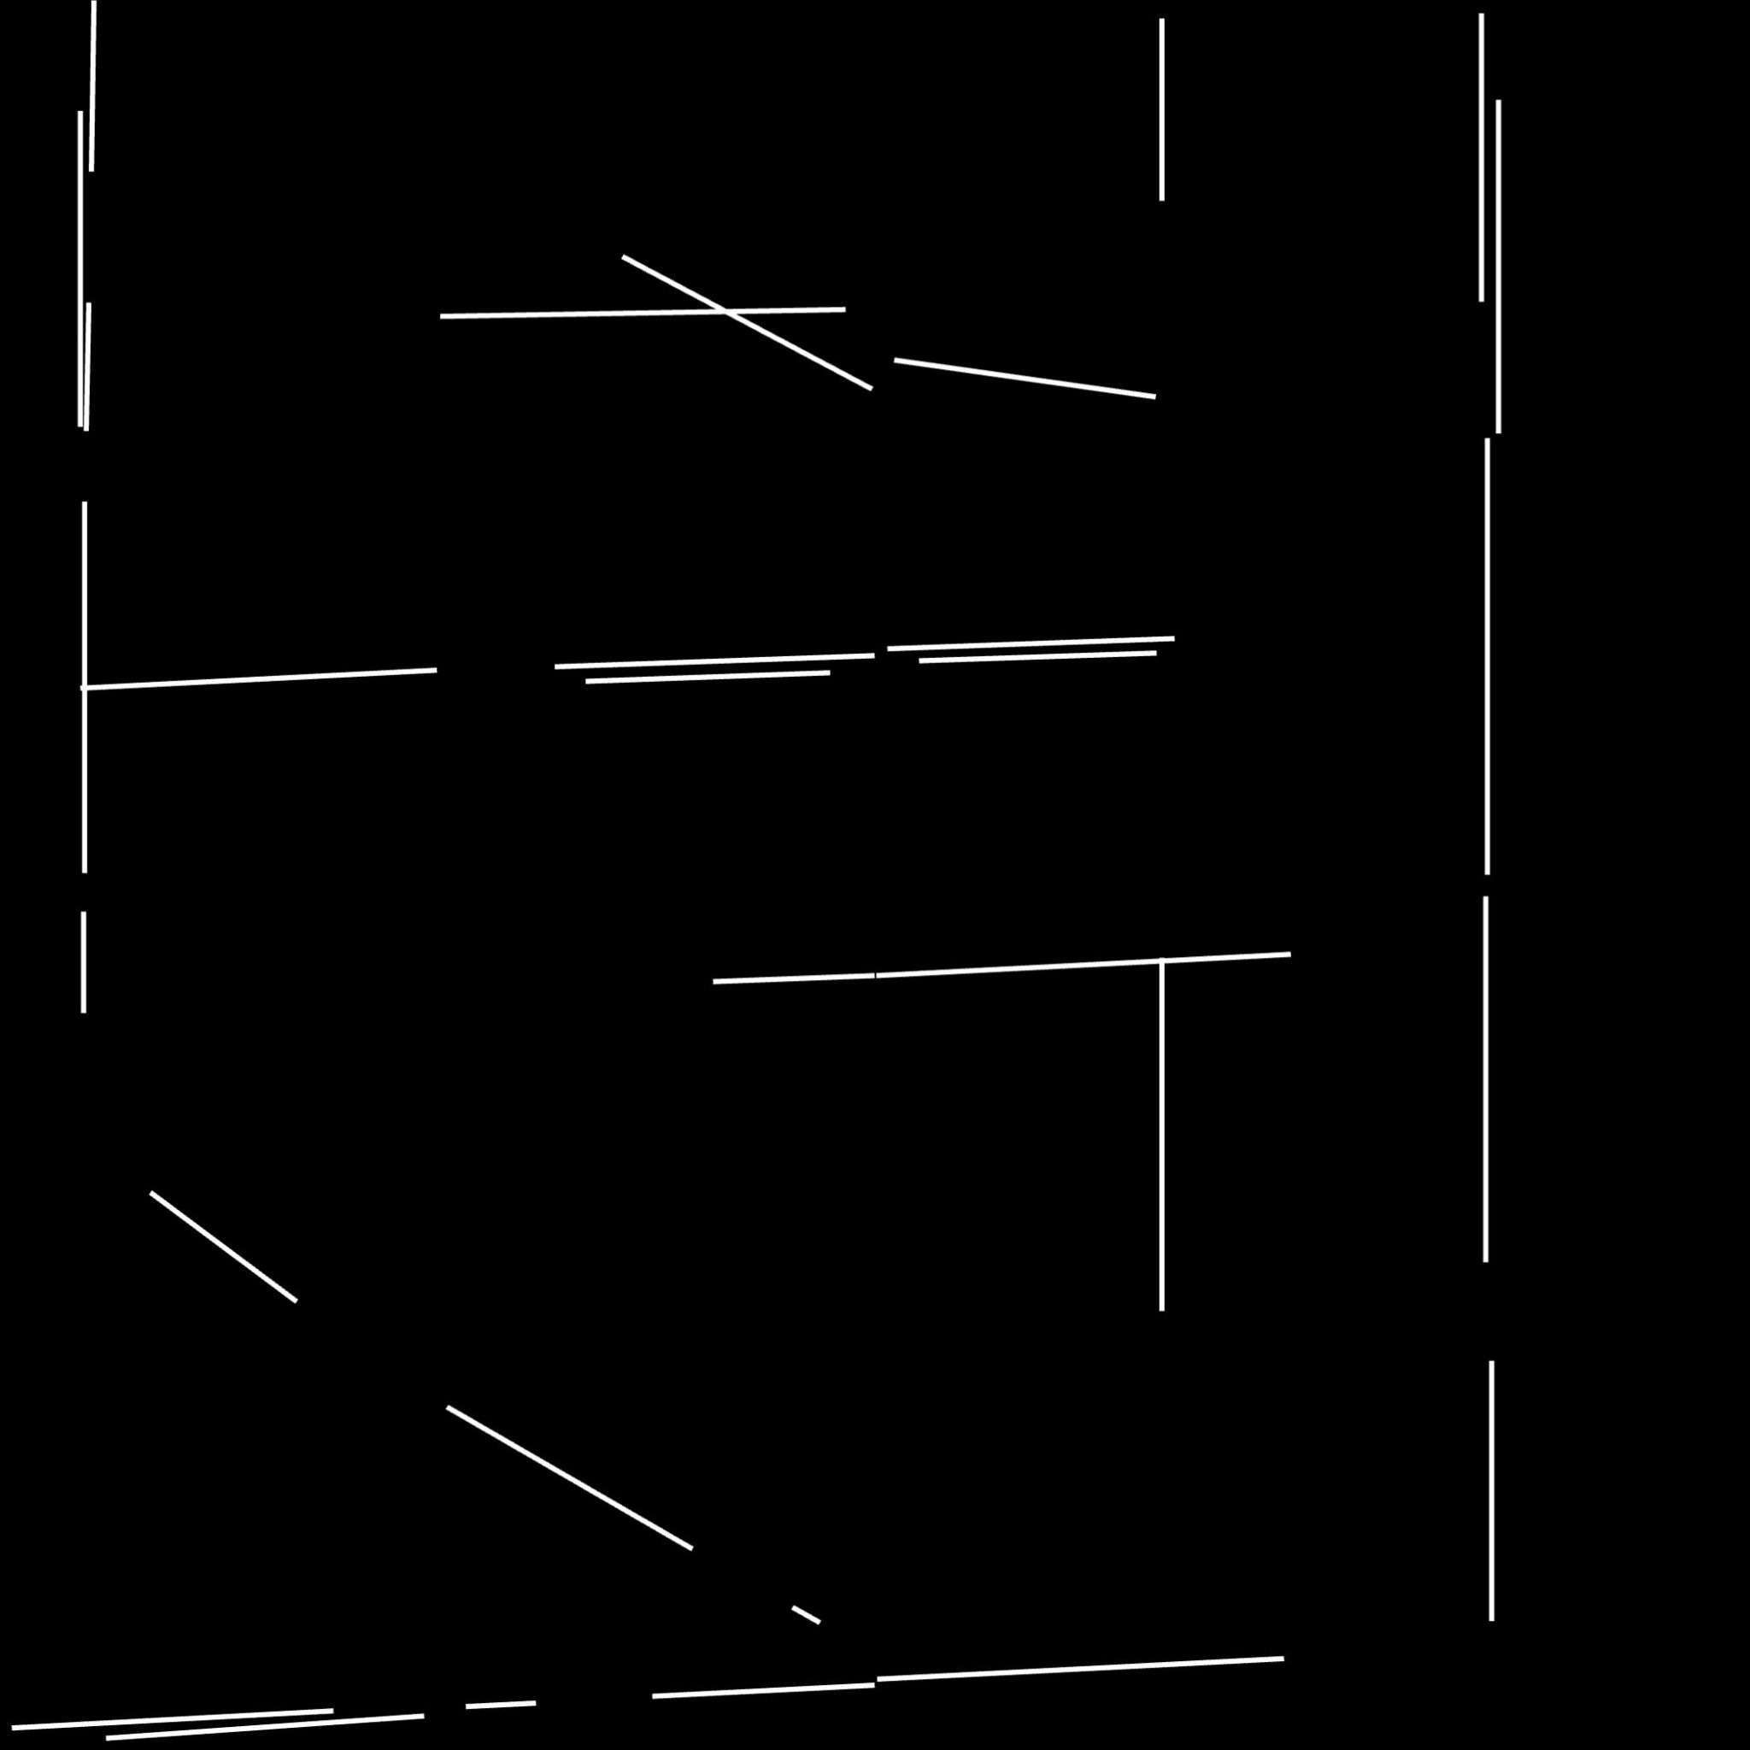

Ground Truth Result

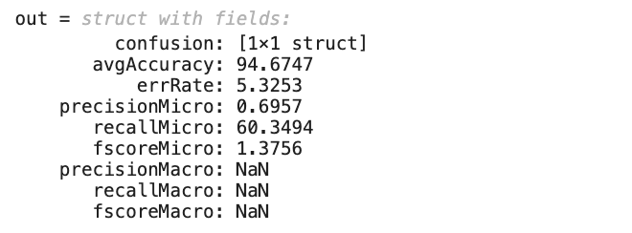

Accuracy from the Confusion Matrix

For L96b.jpg the accuracy is 94.6747 which is great and the shape was similar from looking at the image.

* **L97a.jpg**

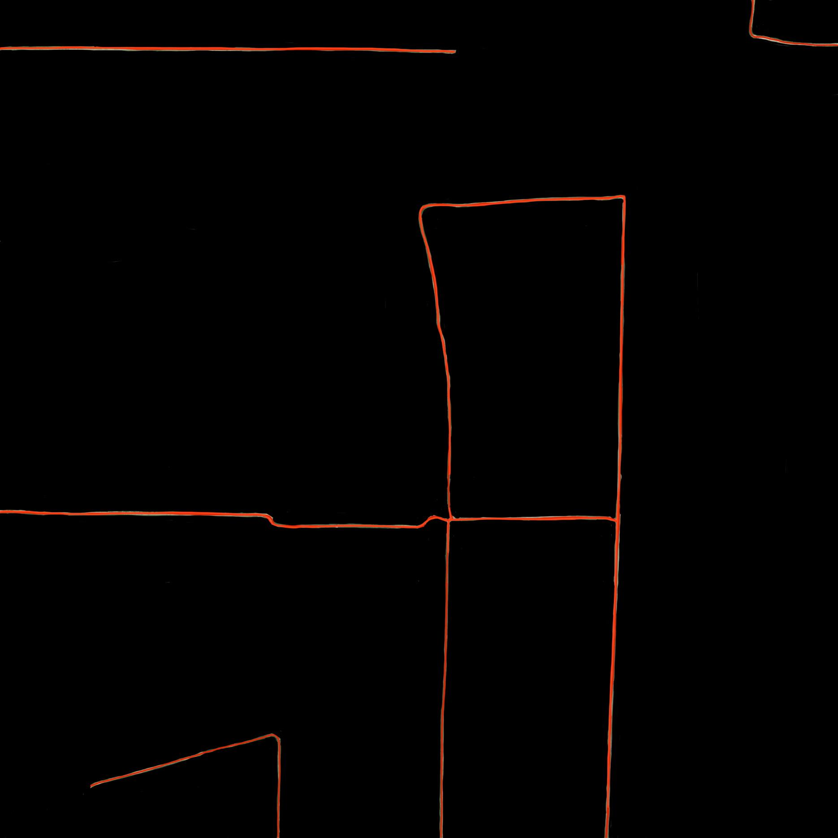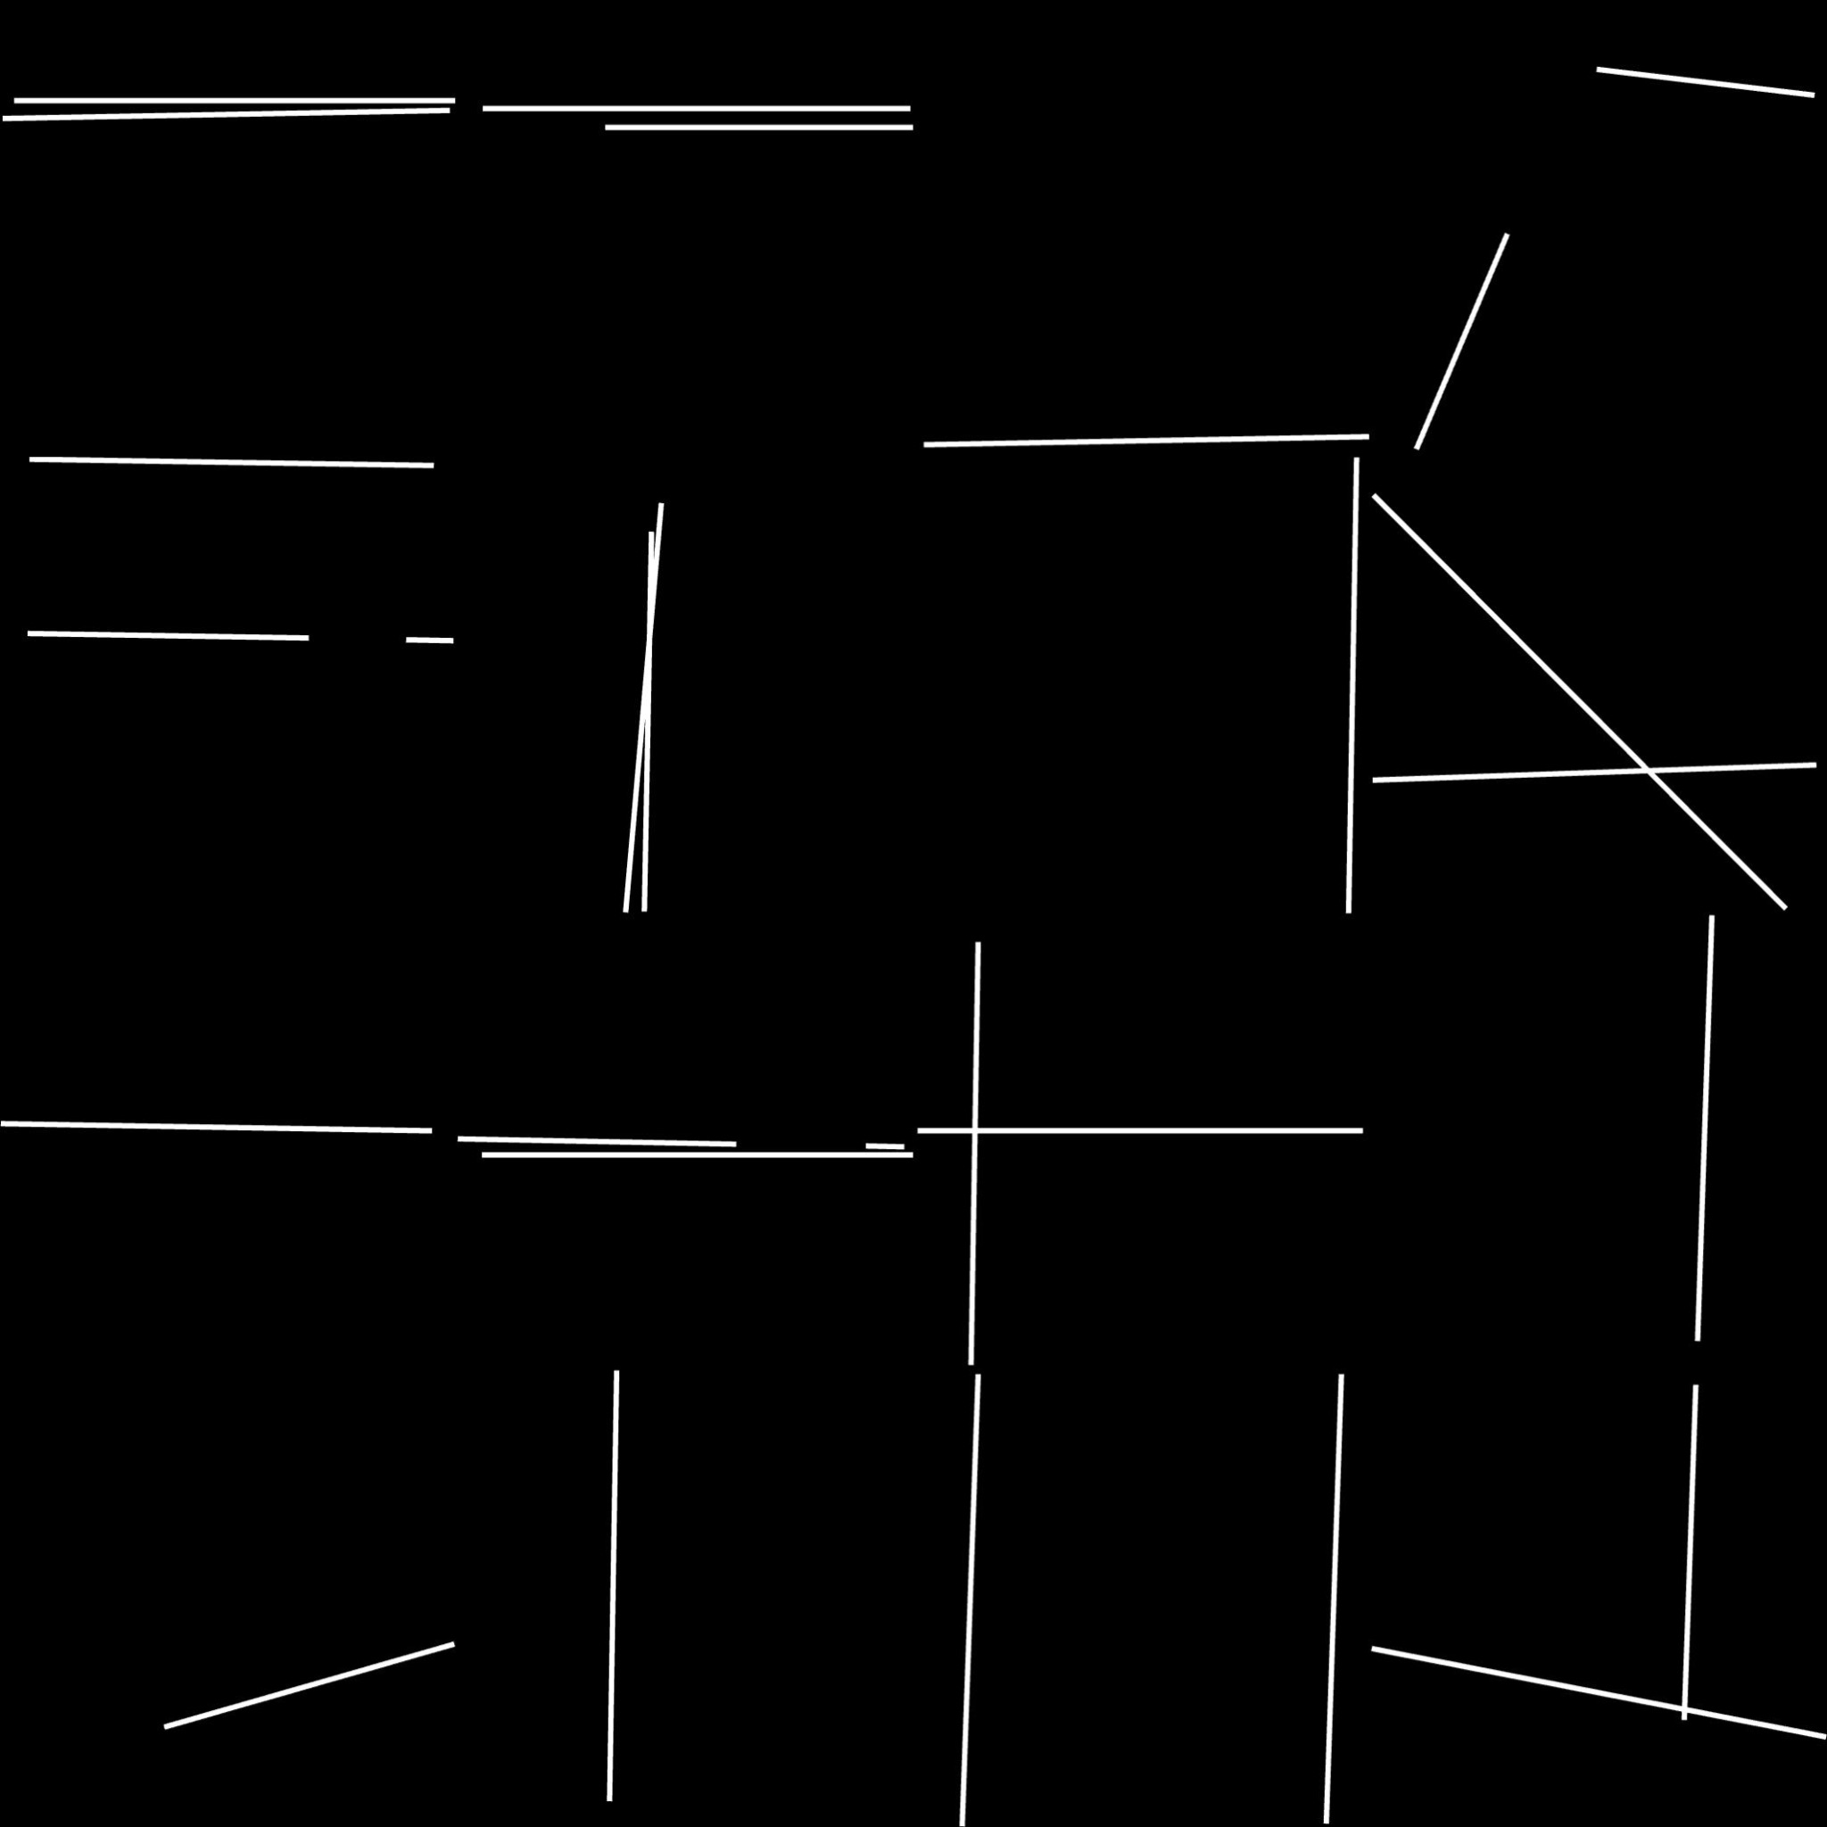

Ground Truth Result

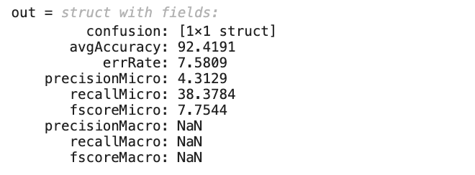

Accuracy from the Confusion Matrix

For L97a.jpg the accuracy is 92.4191 which is great and the shape was similar from looking at the image but there are also some negatives which need to be eliminated.

* **L97b.jpg**

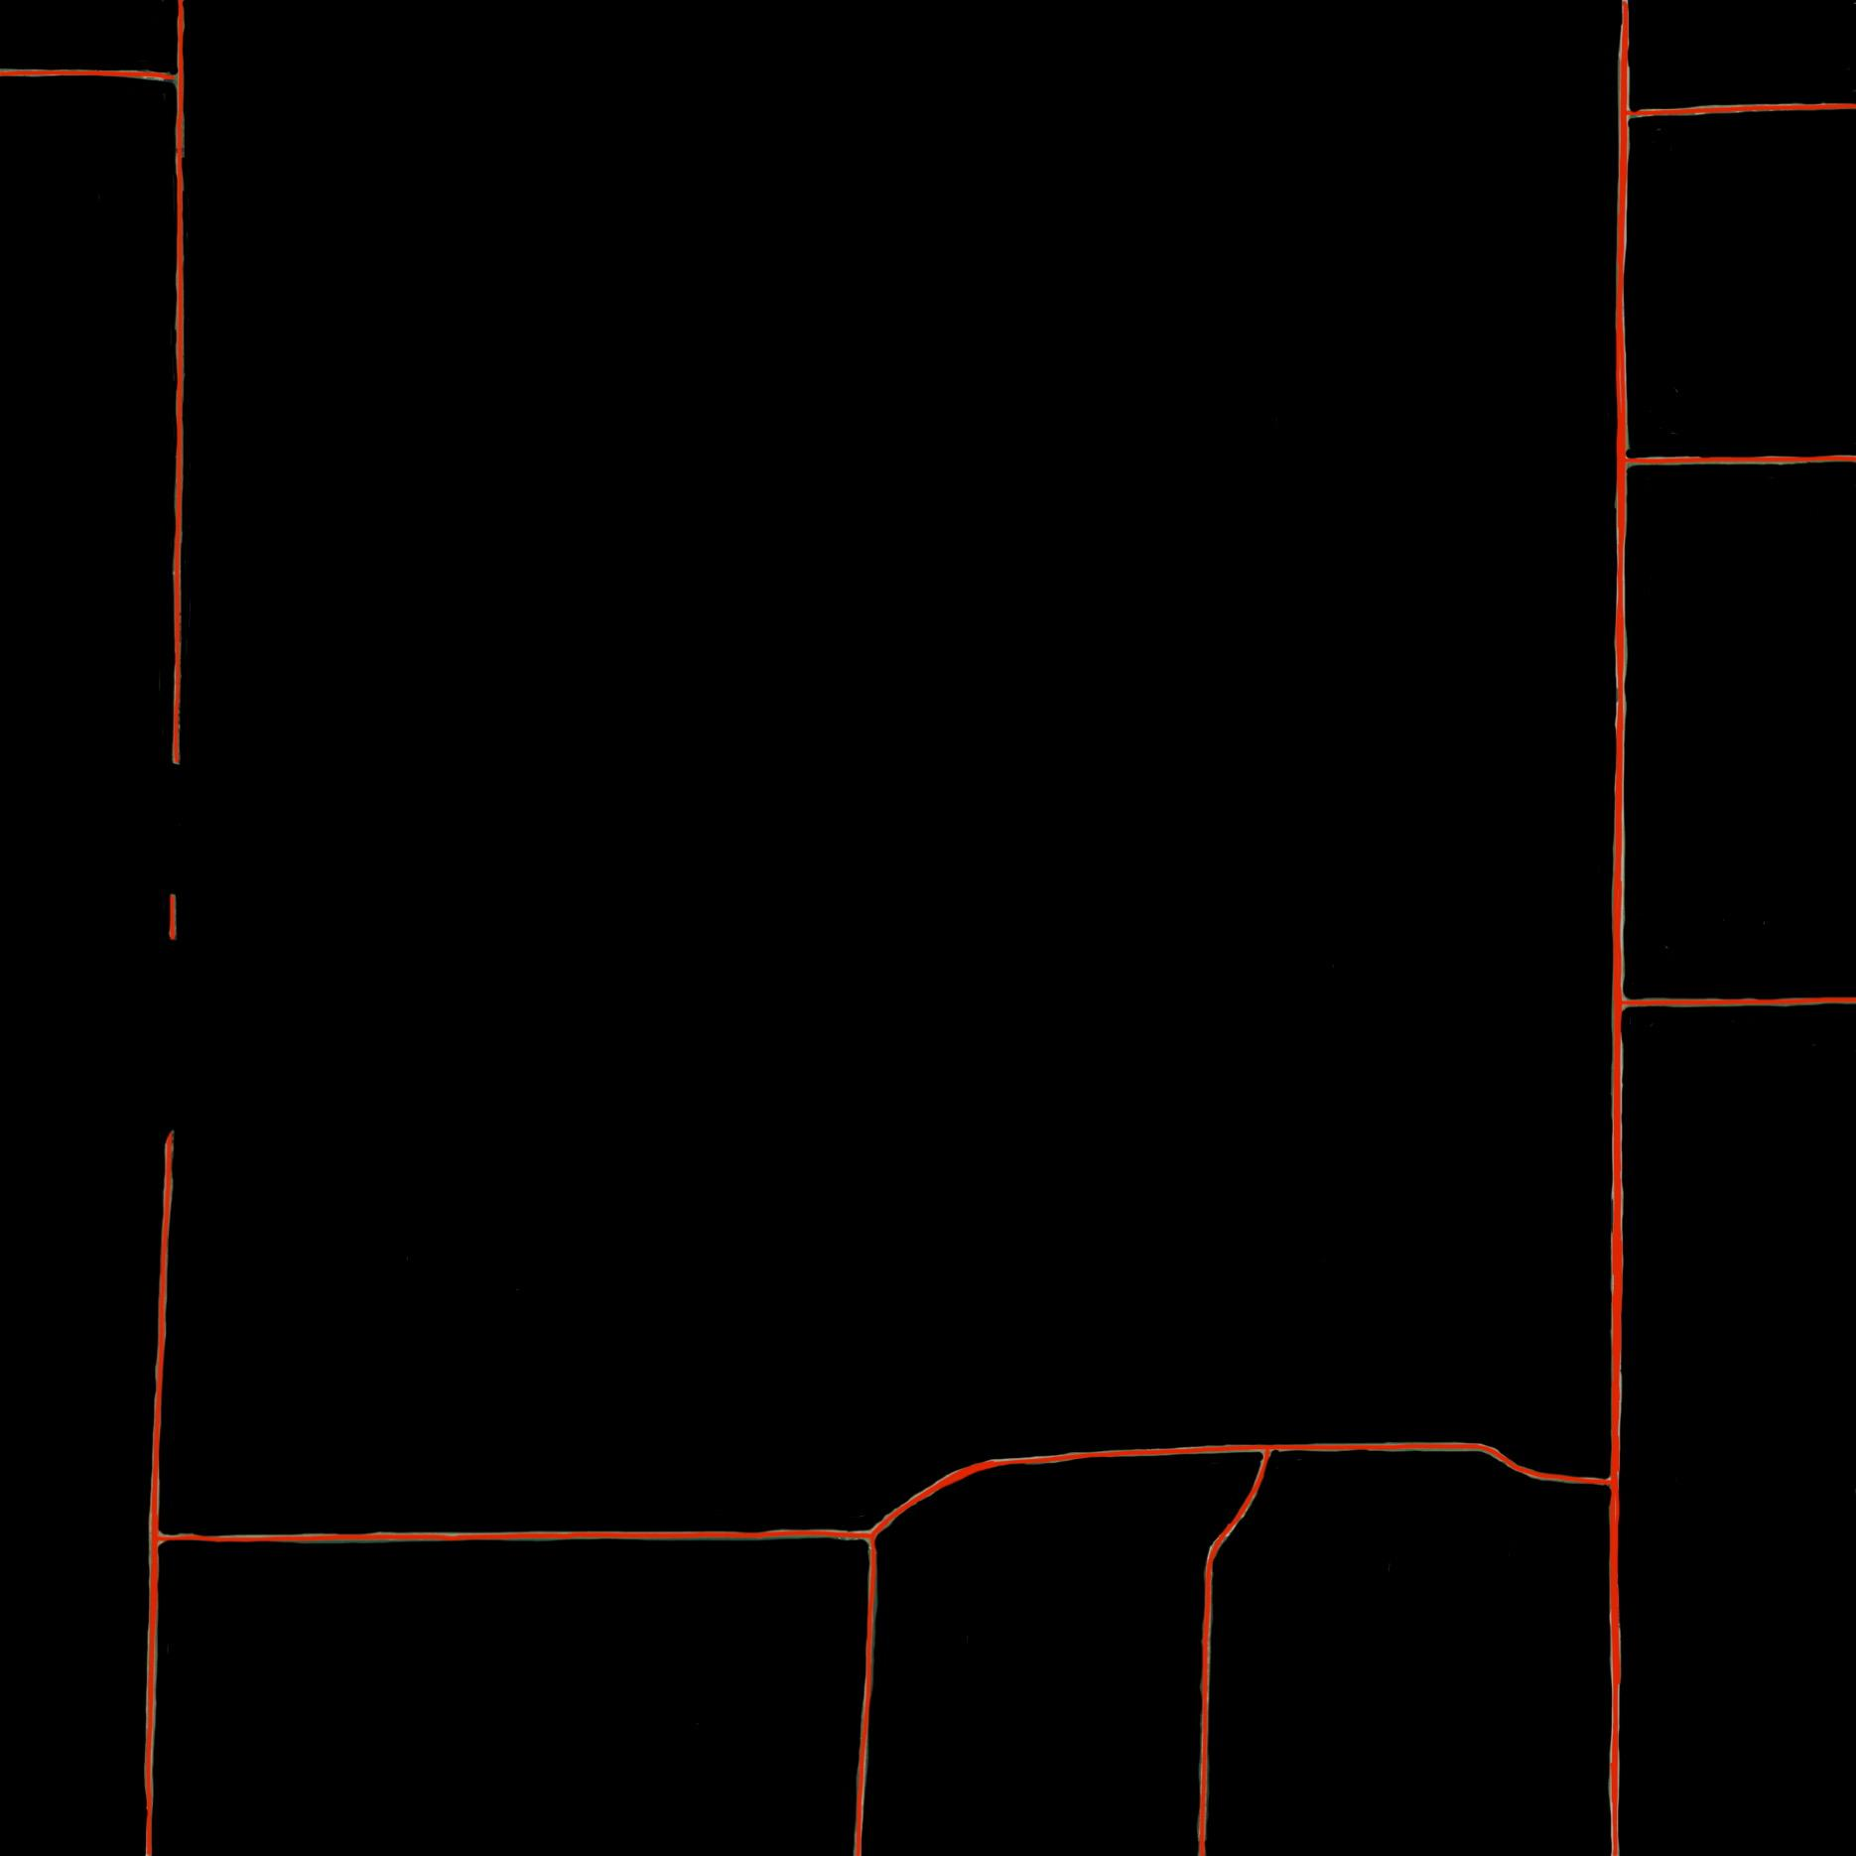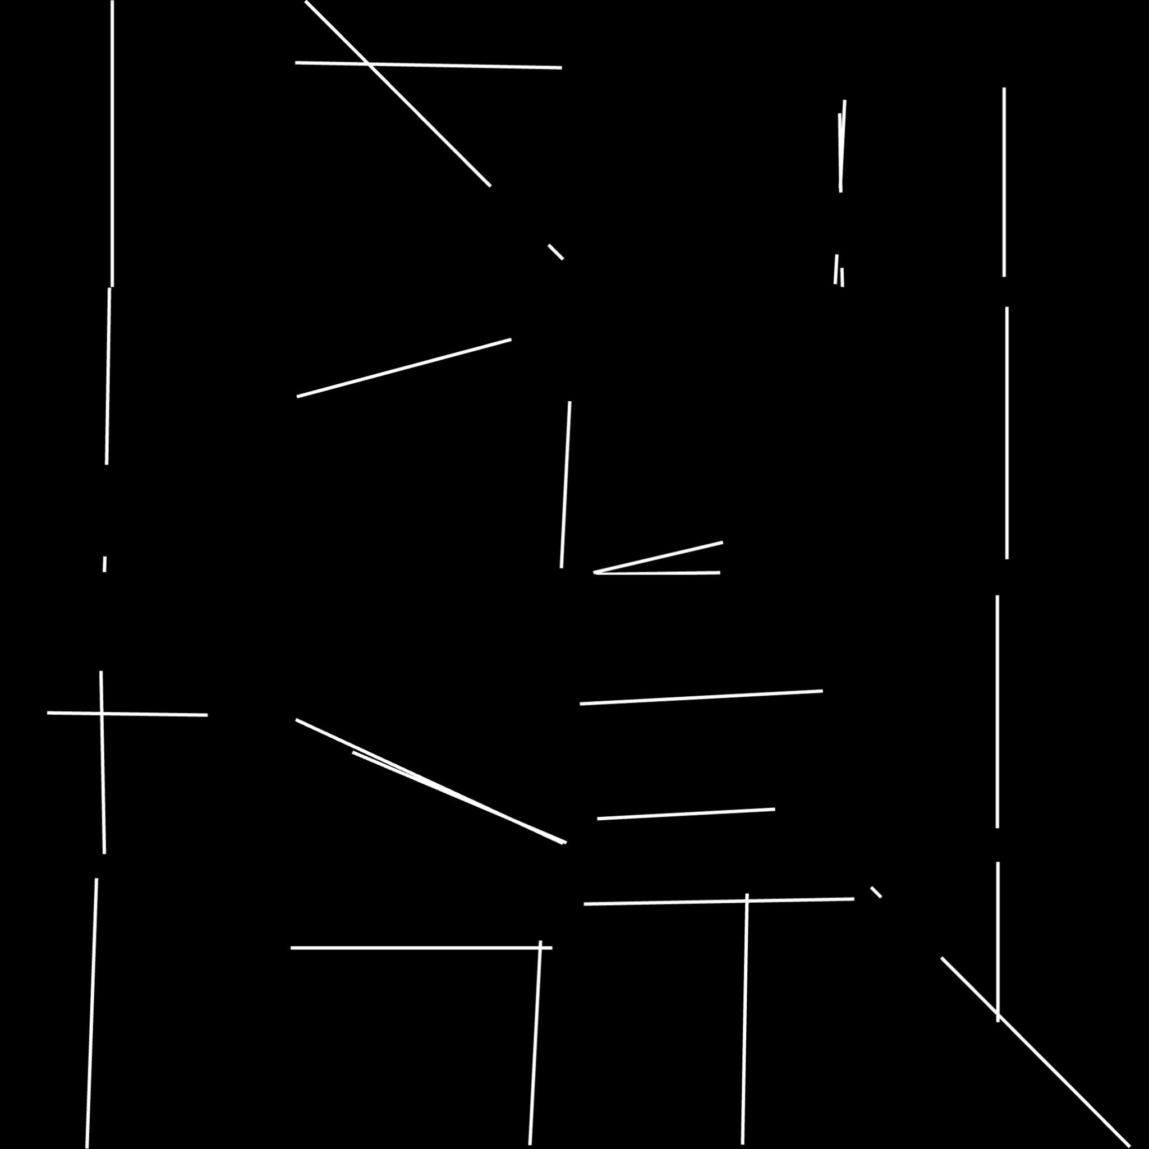

Ground Truth Result

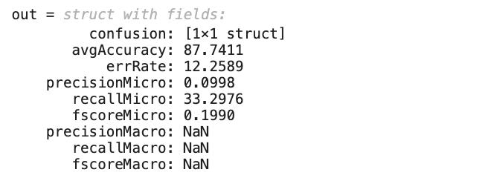

Accuracy from the Confusion Matrix

For L97b.jpg the accuracy is 87.7411 which is good and the shape was similar when looking at the ground truth but there are many negatives to be eliminated.

* **W107a.jpg**

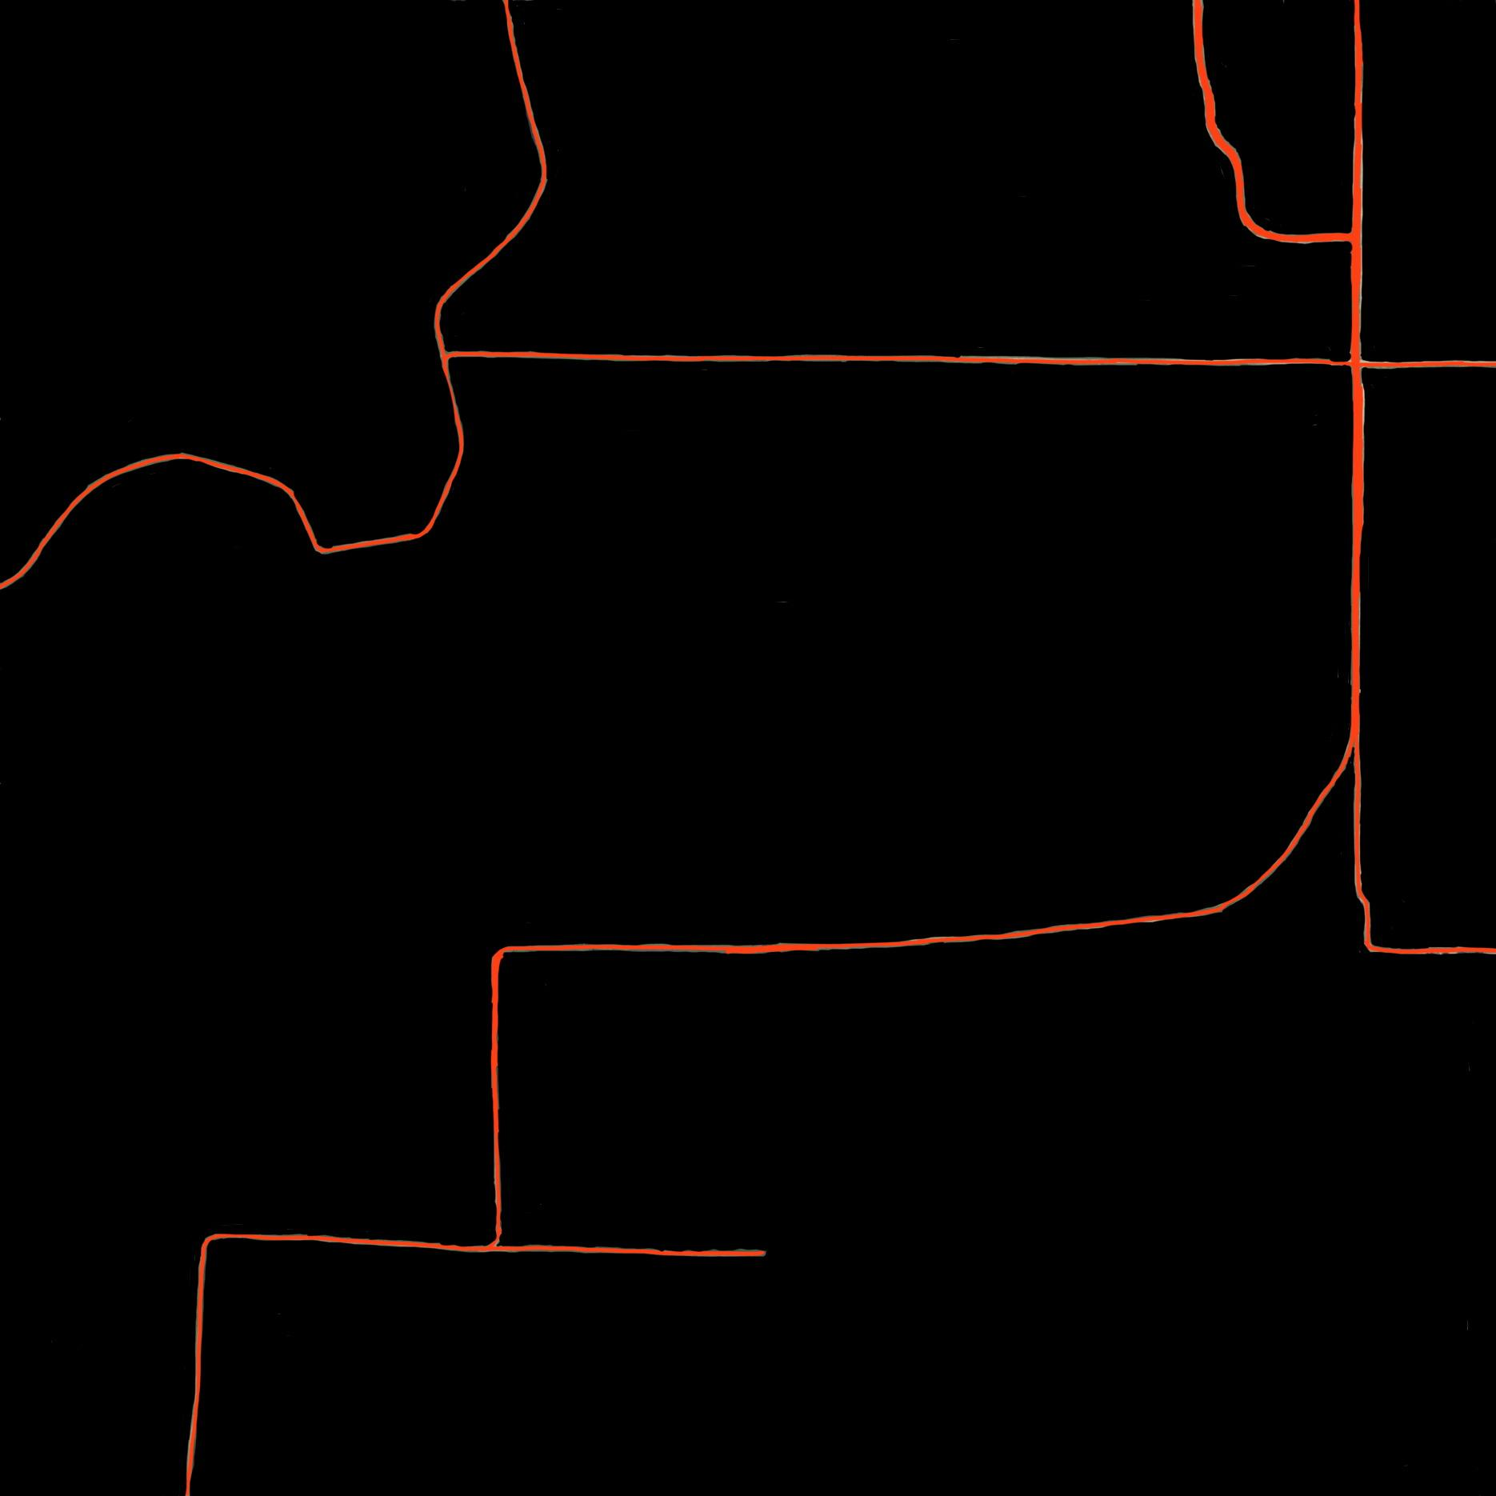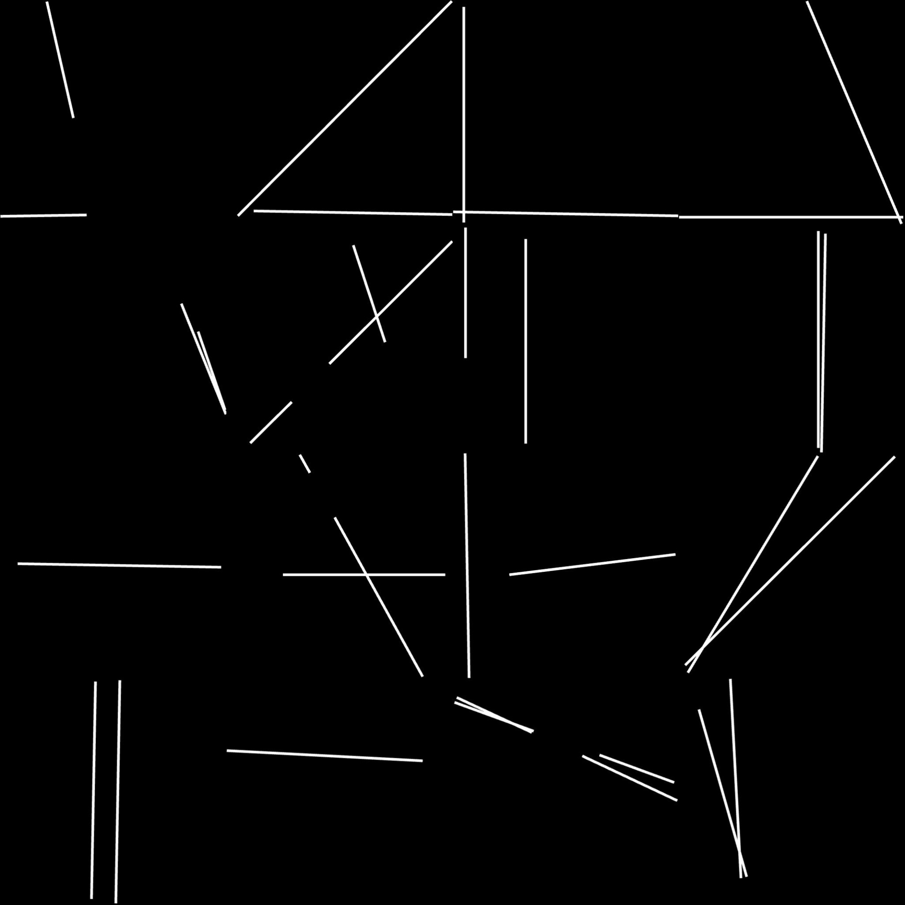

Ground Truth Result

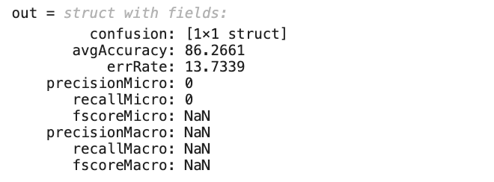

Accuracy from the Confusion Matrix

For W107a.jpg the accuracy is 86.2661 which is good but need to eliminate all the negatives here. The result was not so great because there are more curves in the image.

* **W107b.jpg**

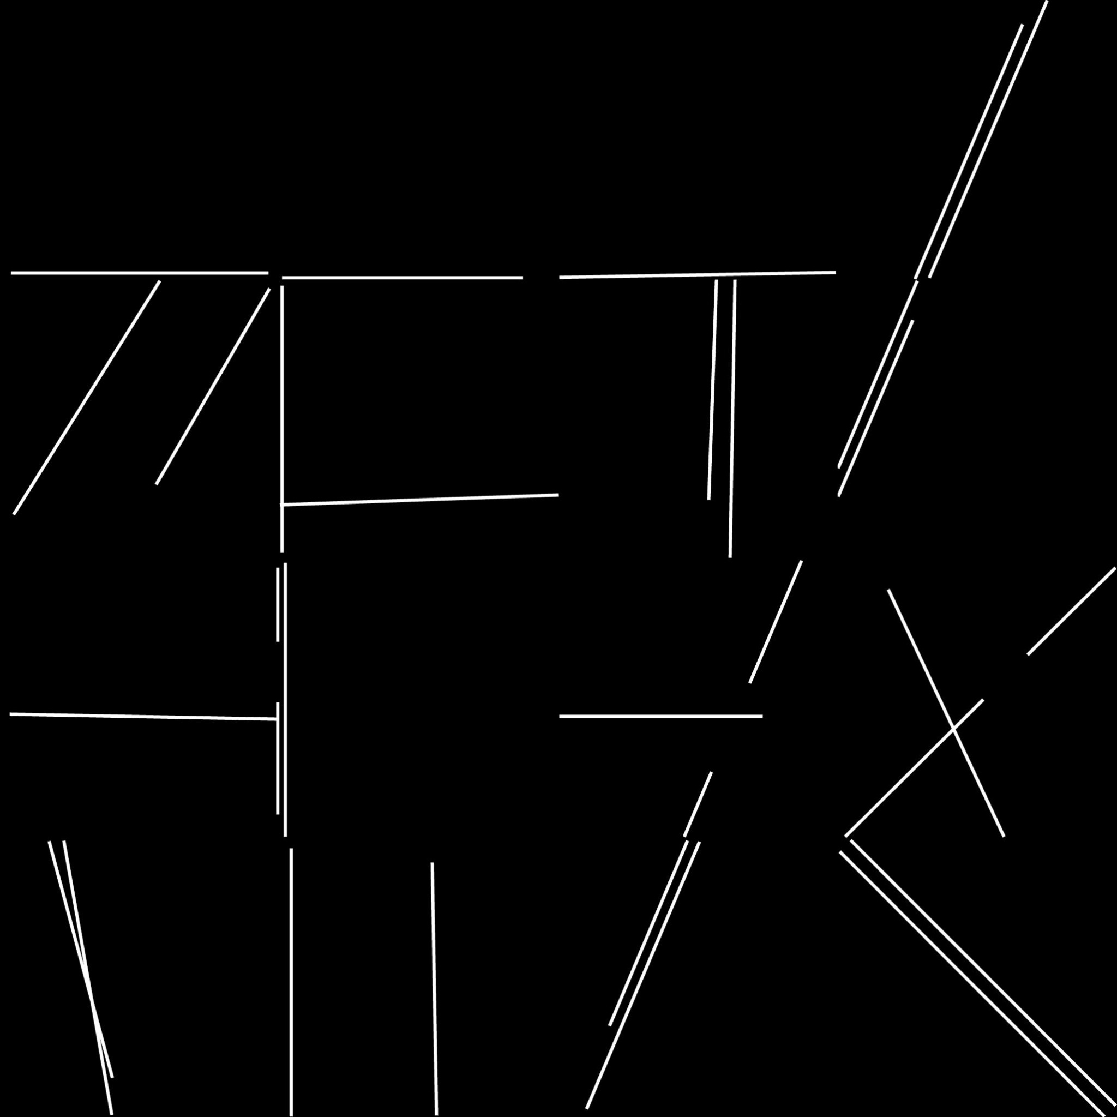

Ground Truth Result

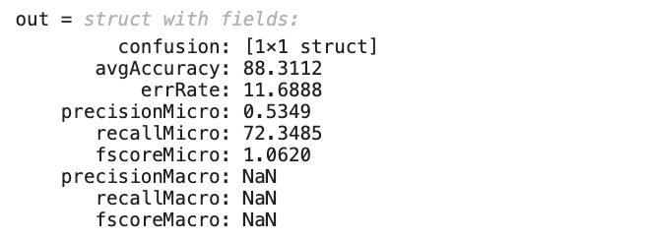

Accuracy from the Confusion Matrix

For W107b.jpg the accuracy is 88.3112 which is great and the shape was similar from looking at the image but there are also some negatives which need to be eliminated.

## **5.** **Discussion**

We divided the images into inorder to get the most number of roads in the images. The advantage of dividing is, when an image is divided into blocks and the hough transform is applied on it, the possibility of detecting the lines increases which also increases the possibility of detecting the roads. But, this process has some disadvantages. It has a possibility of detecting all the corners and results in the increase of false positives. But, when we maintain the correct threshold of dividing an image, the results will be better.

The main reason that we selected to divide the images into 4*4 images is that the results of the original image, 2*2 image and 3*3 images are not good enough as the 4*4 divided images. The precision and the recall for the 4*4 images were high compared to the other images. The results of some images are provided in the experimental results.

By splitting the image into 4x4 subimages, we could apply the Hough Line function to each subimage. Therefore, we improve the number of lines which can be detected. We can also adjust the parameters for each subimage separately, in terms of Number of Lines, Fill Gap, and Minimum Length. However, one disadvantage is that we need to adjust them one by one, and it is time consuming. For example, we have 16 subimages for one original image, and we have to adjust the parameters such as Number of Lines, Fill Gap, and Minimum Length of the houghline function one by one. The reason why we do that is because we want to obtain as many lines as possible without overfitting or underfitting. Let’s say we want to split them into 5x5 or more, we will have a large number of subimages. As a consequence, it requires a large amount of time to process them, and the results are too biassed. In that situation, we would need a function that could adjust those parameters automatically. In other words, the function must be trained and learned from other subimages to perform the best results. For the evaluation step, by using the confusion matrix, we used the most efficient way of evaluating the results.

## **6. Conclusion**

In this paper, road detection from satellite images is processed by Hough Line transform. In order to improve the accuracy of road detection, we need to improve the houghline function and split the image into the proper number of blocks. The results show that the accuracy rate is improved when we split the image into 4x4 instead of 3*3 or 2*2. Also, instead of comparing pixel by pixel, we use a confusion matrix as an evaluation method. Hence, this new evaluation method works correctly as we expected.

However, due to the limited time, we could not develop a houghline function in a more efficient way. Instead of adjusting those houghline parameters one by one block separately (such as Number of Lines, Fill Gap, and Minimum Length), the function should adjust those parameters automatically. We need to have more image data which could be split into training sets and testing sets. Instead of developing the only function, we develop a model that generalises well to new image data. Our training set will be a subset to train a model, and our test set serves as a proxy for new image data.

## **7. References:**

[1] Malpani, S,; Kamble, S.; Chavan, M.; Nagpure, R. Road Detection from Satellite Images. In International Journal of Engineering and Technology (IRJET)*,* February 2020; pp. 2497-2501. Available online: <https://www.irjet.net/archives/V7/i2/IRJET-V7I2523.pdf> (accessed on December 10 2022)

[2] Assidiq, A.A.; Khalifa, O.O.; Islam, M.R.; Khan, S. Real time lane detection for autonomous vehicles. In Proceedings of the 2008 International Conference on Computer and Communication Engineering, Kuala Lumpur, Malaysia, 13–15 May 2008; pp. 82–88. Available online: https://ieeexplore.ieee.org/abstract/document/4580573 (accessed on December 10 2022)

[3] Devane, V.; Sahane, G.; Khairmode, H.; Datkhile, G. Lane Detection Techniques using Image Processing. In Proceedings of the ITM Web Conference, Navi Mumbai, India, 14–15 July 2021; Volume 40, p. 03011.